# E:\3S\Develop\Users\HuyTDH\SAD\PNG\KW_DD_HuyTDH_ver1.0\DD_CD_002 Angular Module.pngMobile Application For Shipper

***Shipper Sign in***

***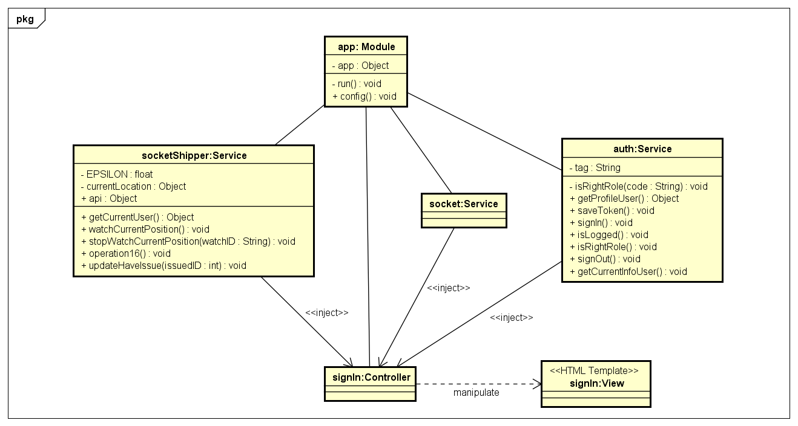***

***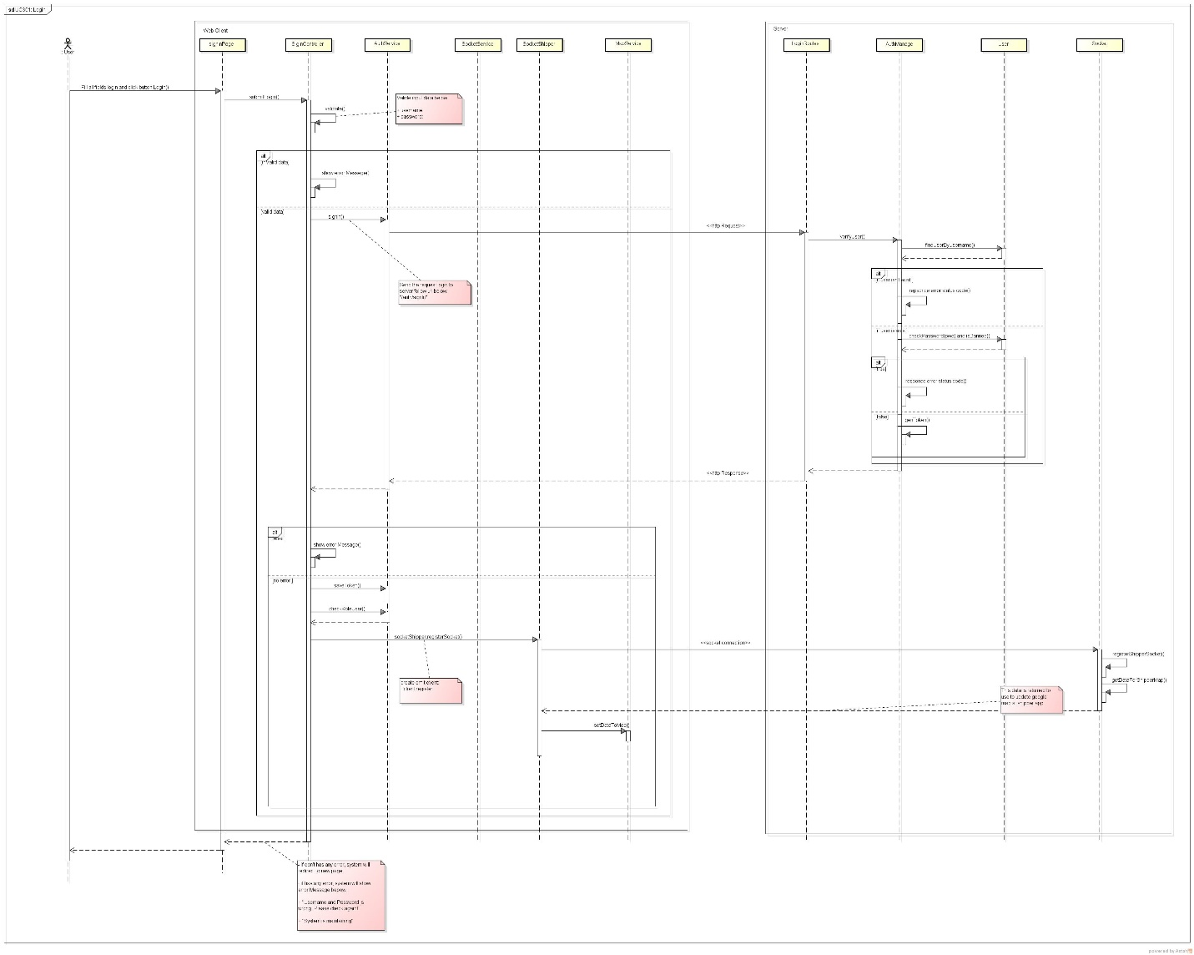***

***305 Shipper View Profile***

***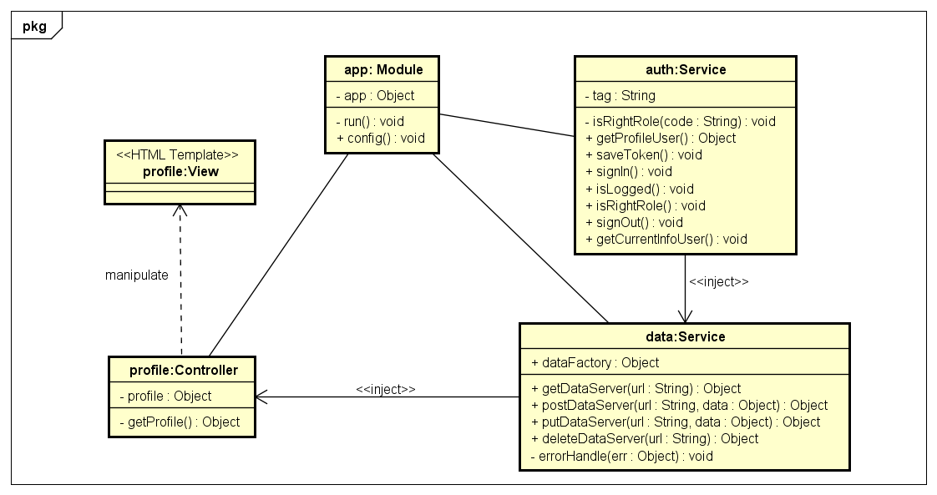***

***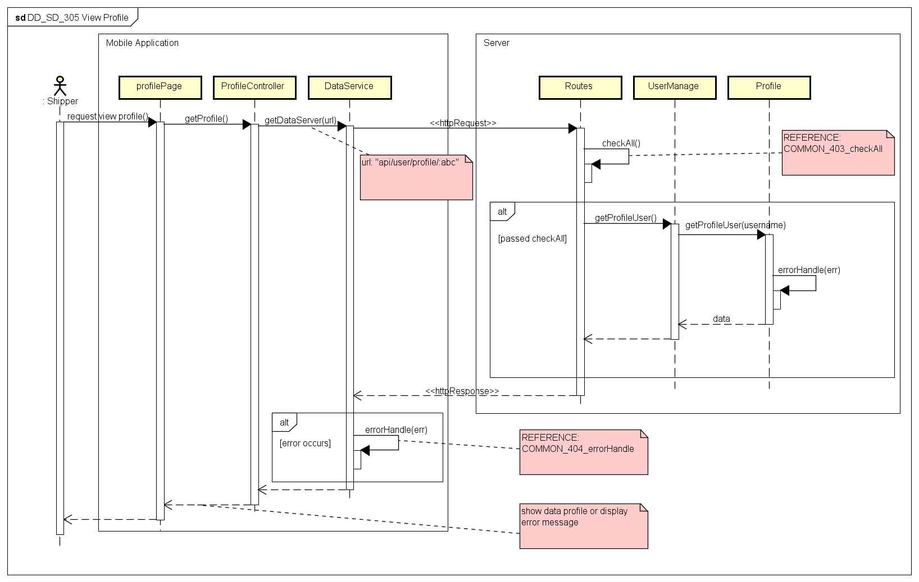***

***307 Confirm Code***

***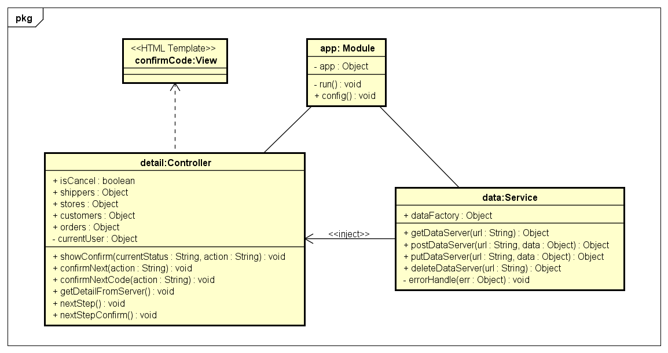***

***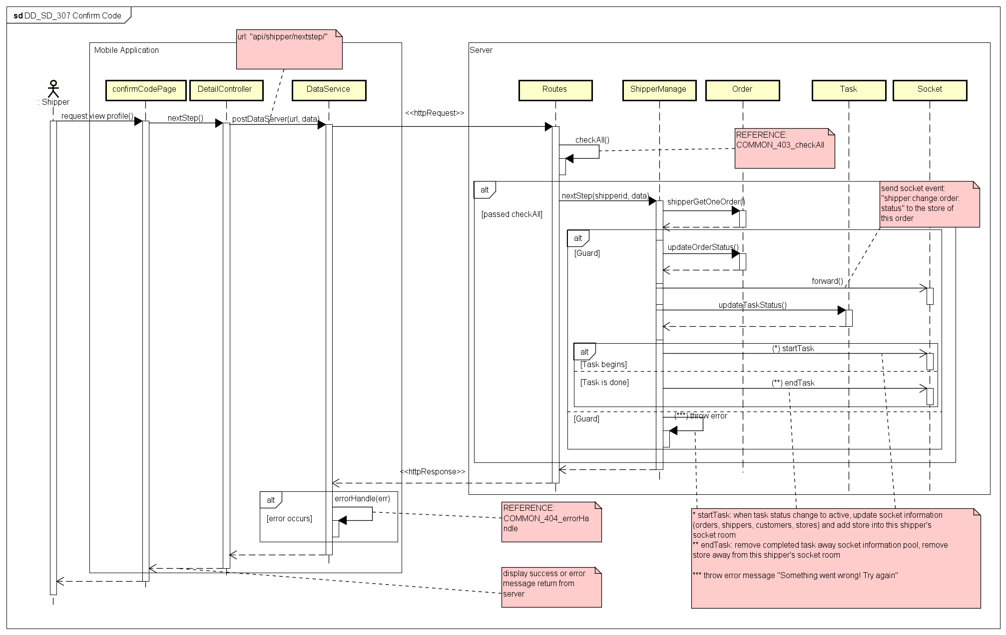***

***308 Grab Order***

***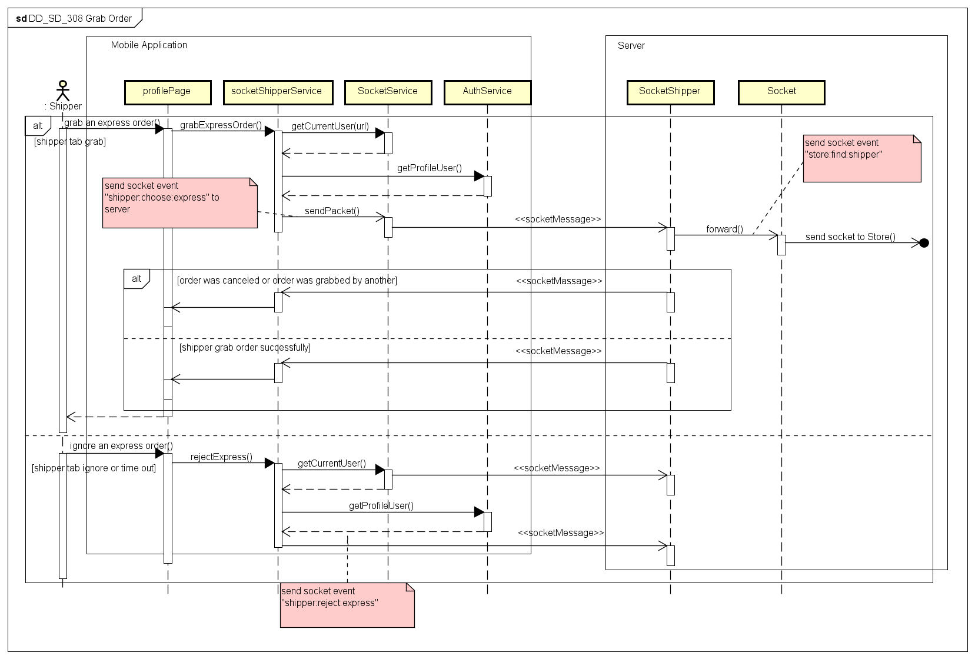***

***309 View List Task***

***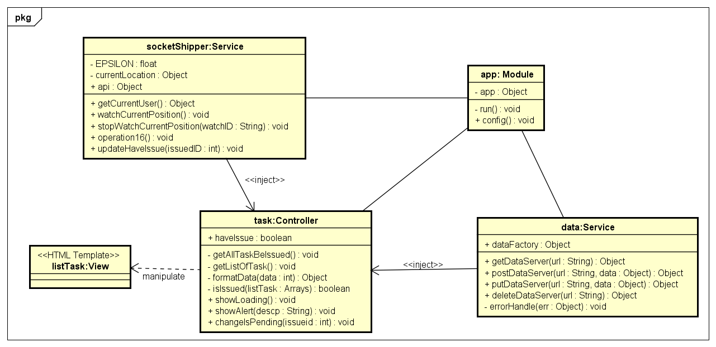***

***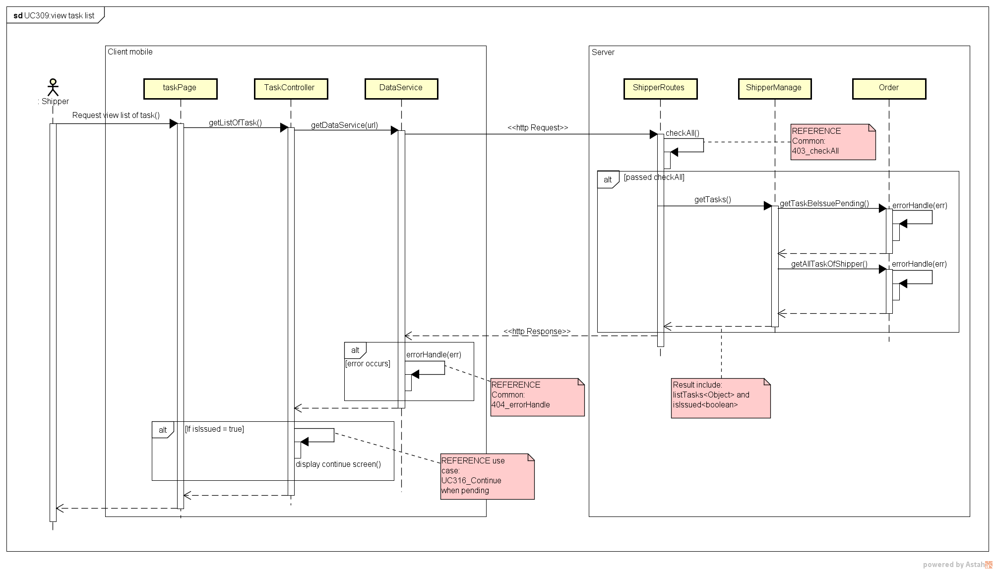***

***311 View Detail***

***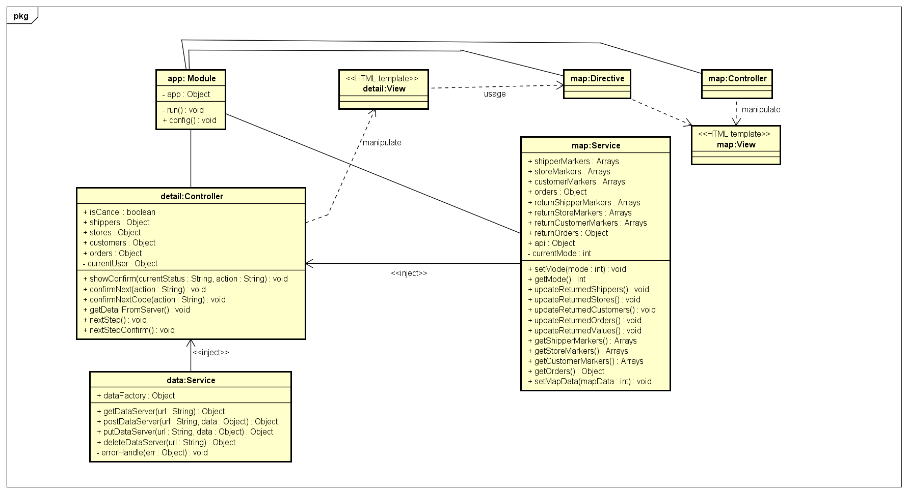***

***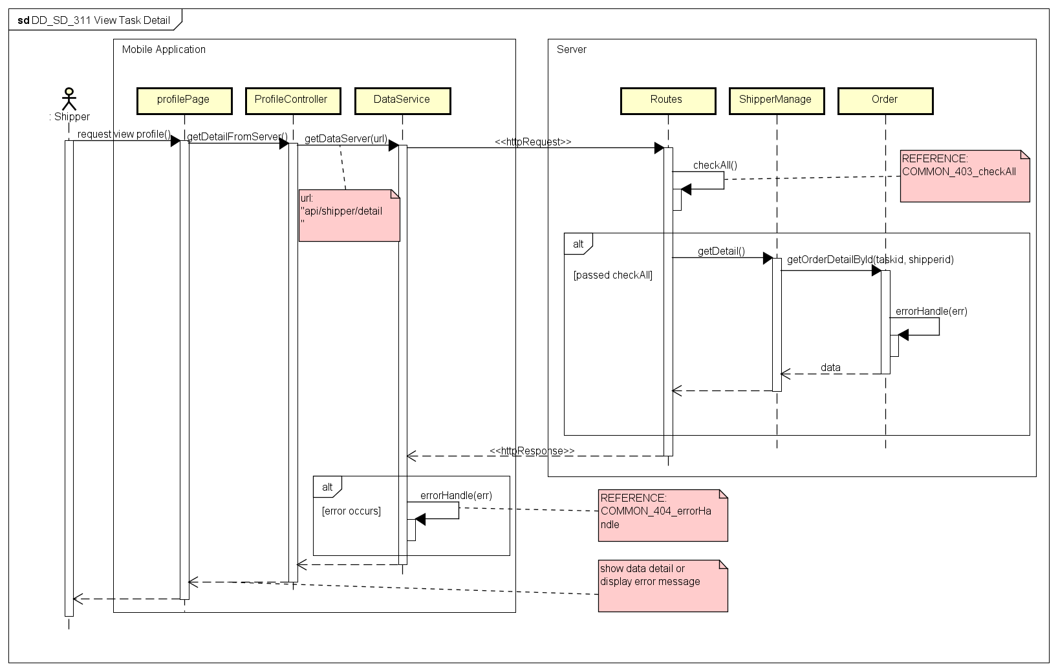***

***313 Send Issue***

***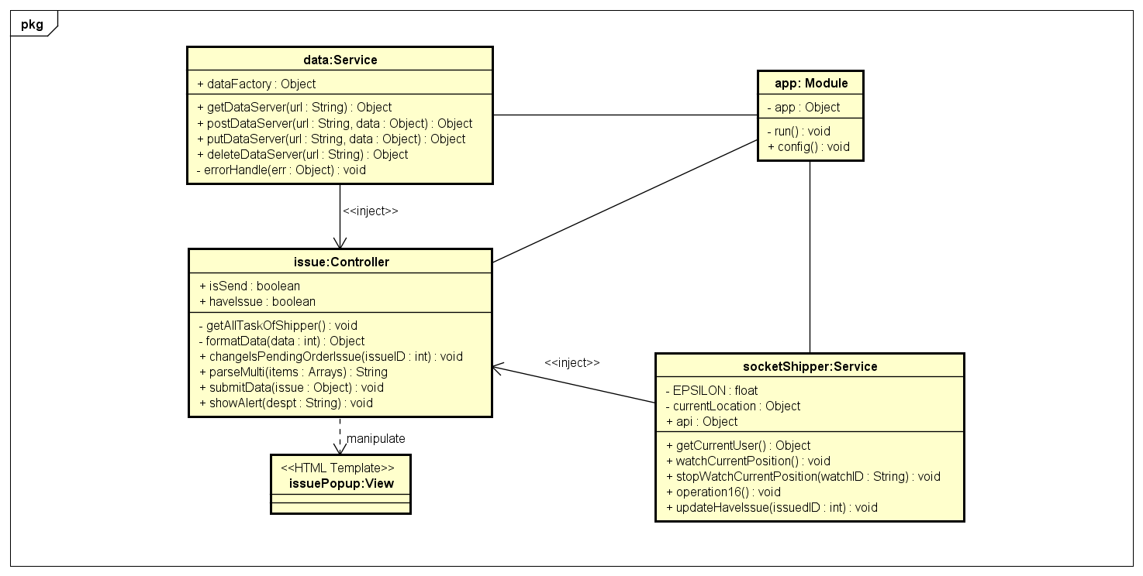***

***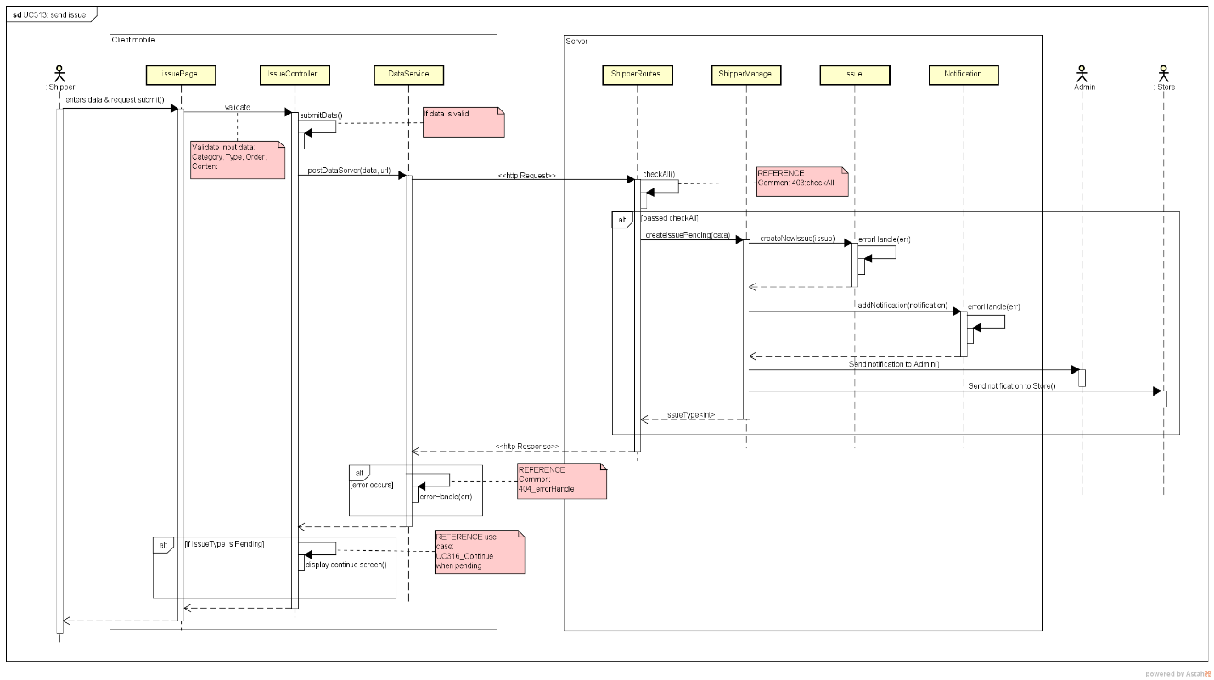***

***314 Change Status***

***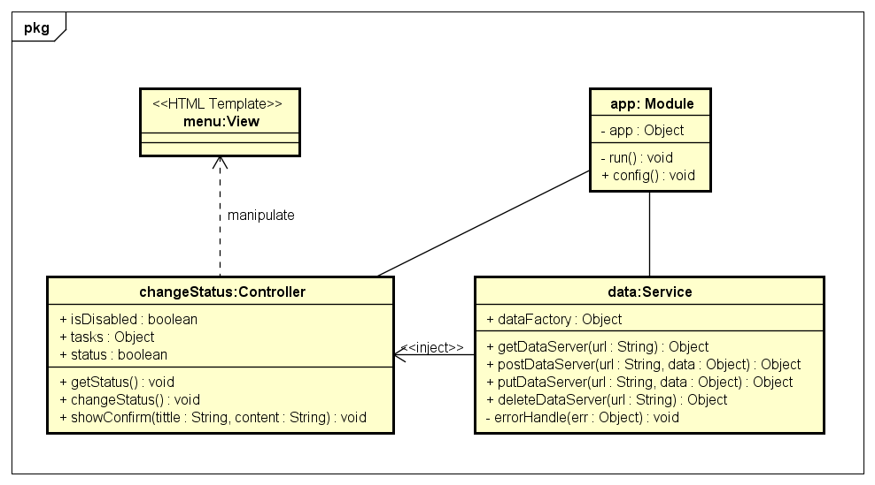***

***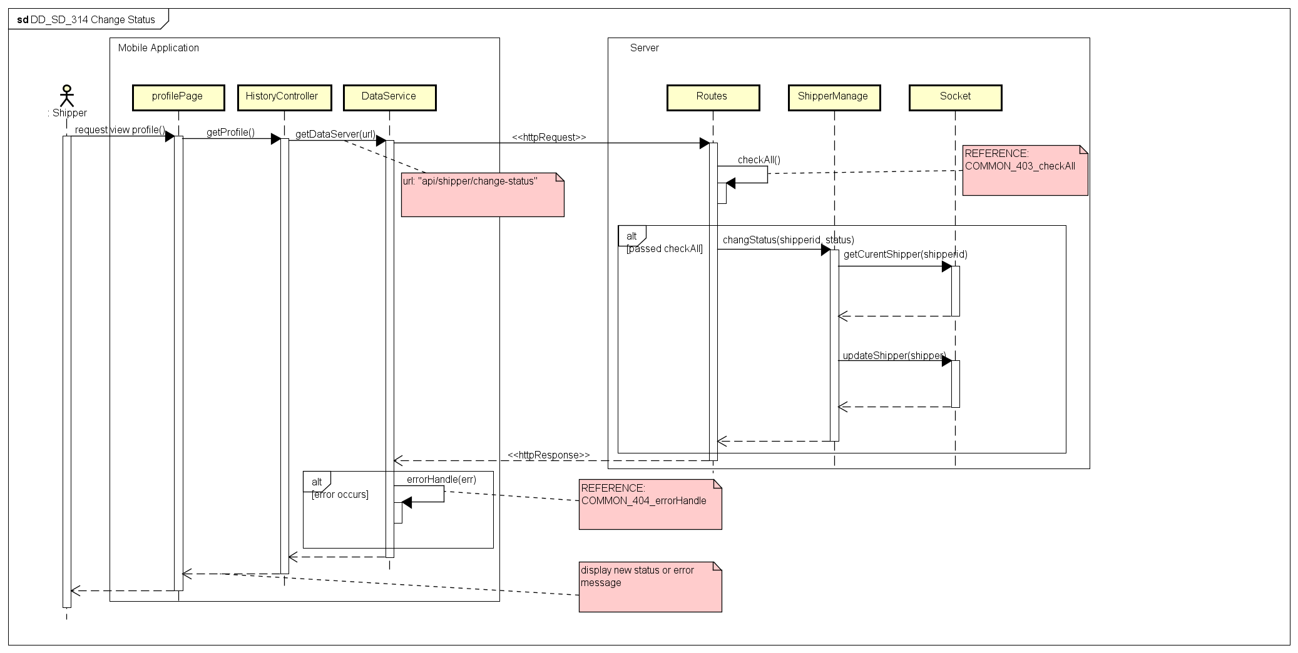***

***315 View History***

***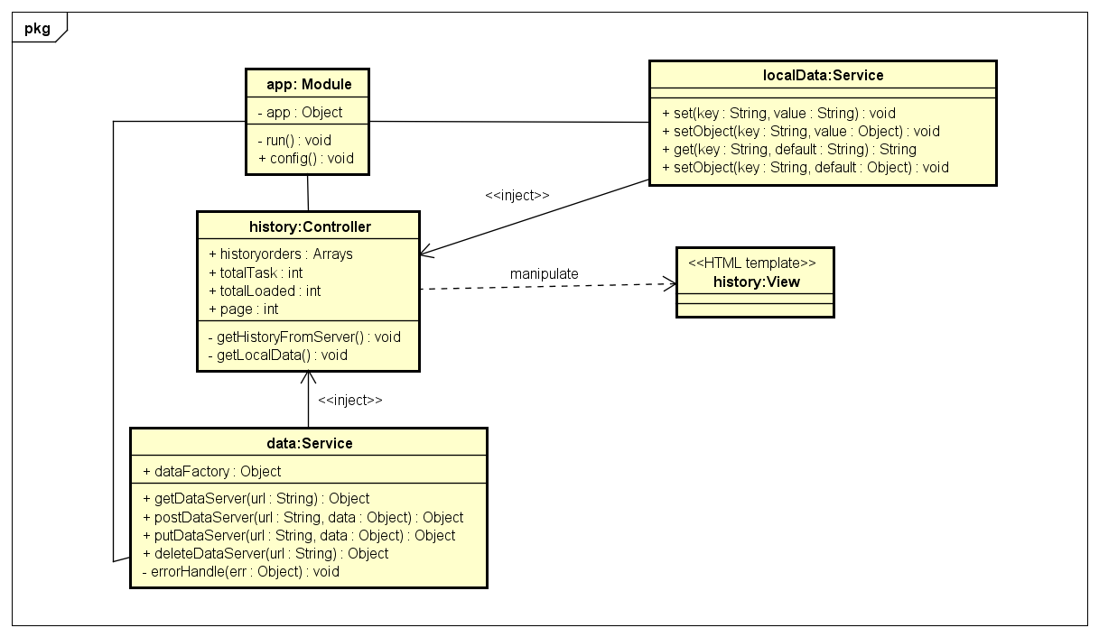***

***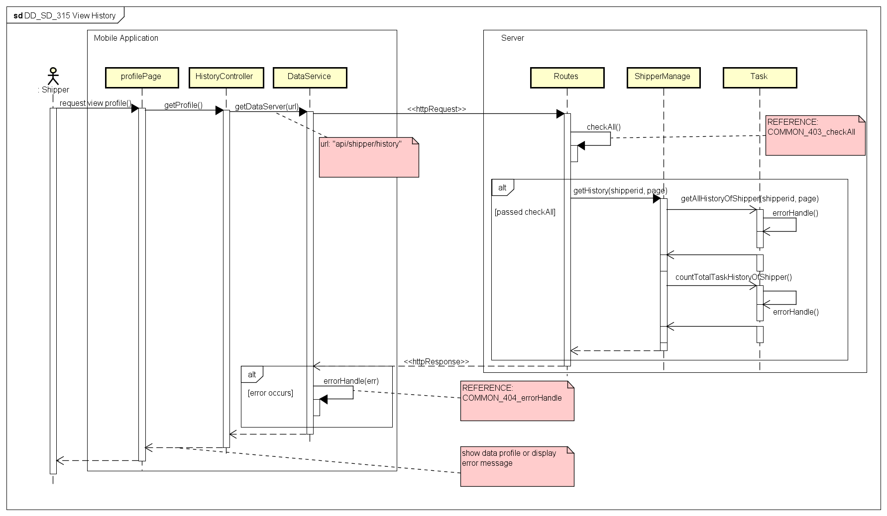***

***316\_Continue When Pending***

***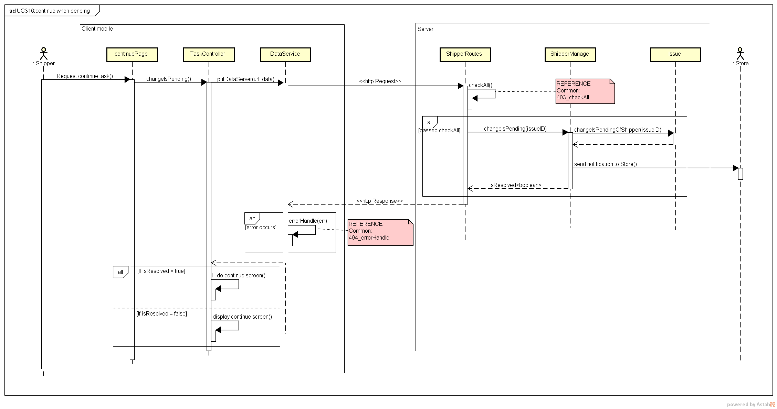***

***CLASS DESCRIPTION***

1. SigninController

Attributes

|  |  |  |  |  |
| --- | --- | --- | --- | --- |
| No | Attributes | Type | Default | Description |
|  | User | Object | {} | Content information of logged in user |

Methods

|  |  |  |  |  |
| --- | --- | --- | --- | --- |
| No | Methods | Parameters | Return | Description |
| 1 | showError | Object | N/A | Show message error to user |
| 2 | submitFrm | N/A | N/A | Send login request to server |
| 3 | logout | N/A | N/A | Sign out, clear token save in local |

1. DetailController

Attributes

|  |  |  |  |  |
| --- | --- | --- | --- | --- |
| No | Attributes | Type | Default | Description |
| 1 | isCancel | boolean | N/A | Is the current order canceled? |
| 2 | Shippers | Object | N/A | Information of shipper to display in map |
| 3 | Stores | Object | N/A | Information of stores to display in map |
| 4 | Customers | Object | N/A | Information of customers to display in map |
| 5 | Orders | Object | N/A | Information of orders that the shipper is having, to connect markers on map |
| 6 | Center | Object | {} | The center of the map |

Methods

|  |  |  |  |  |
| --- | --- | --- | --- | --- |
| No | Methods | Parameters | Return | Description |
| 1 | showConfirm | int, String | N/A | Show the pop up to confirm when shipper want to move to next step |
| 2 | confirmNext | String | N/A | Send request to server without confirmation code |
| 3 | confirmNextCode | String | N/A | Send request to server with a confirmation code regard to current task and current status |
| 4 | getDetailFromServer | N/A | N/A | Get detail information of task from server |

1. HistoryController

Attributes

|  |  |  |  |  |
| --- | --- | --- | --- | --- |
| No | Attributes | Type | Default | Description |
| 1 | historyOrders | Array | [] | Current loaded history |
| 2 | totalTask | int | 0 | The number of total tasks of the shipper |
| 3 | totalLoaded | int | 0 | The number of total tasks that displayed |
| 4 | Page | int | 1 | Last displayed page of history |

Methods

|  |  |  |  |  |
| --- | --- | --- | --- | --- |
| No | Methods | Parameters | Return | Description |
| 1 | getHistoryFromServer | int | N/A | Load data history from server |
| 2 | getLocalData | N/A | N/A | Load data history from local storage |

1. IssueController

Attributes

|  |  |  |  |  |
| --- | --- | --- | --- | --- |
| No | Attributes | Type | Default | Description |
| 1 | isSend | boolean | False | If the issue is send or not |
| 2 | haveIssue | boolean | False | If the shipper is having issue or not |
| 3 | issueCategories | Array | [] | List categories of issue |
| 4 | listReasons | Array | [] | List reasons of issue |
| 5 | pendingReasons | Array | [] | List reasons to pending a task |
| 6 | cancelReasons | Array | [] | List reason to cancel a task |

Methods

|  |  |  |  |  |
| --- | --- | --- | --- | --- |
| No | Methods | Parameters | Return | Description |
| 1 | getAllTaskOfShipper | N/A | N/A | Get list current tasks of the shipper |
| 2 | formatData | Object | Object | Format data to display in view |
| 3 | parseMulti | Array | String | Parse a list into a string |
| 4 | showLoading | N/A | N/A | Show a loading icon on the screen |

1. ProfileController

Attributes

|  |  |  |  |  |
| --- | --- | --- | --- | --- |
| No | Attributes | Type | Default | Description |
| 1 | Profile | Object | {} | Profile information of the shipper |

Methods

|  |  |  |  |  |
| --- | --- | --- | --- | --- |
| No | Methods | Parameters | Return | Description |
| 1 | getProfile | N/A | N/A | Request into server to get profile information of shipper display to screen |

1. TaskController

Attributes

|  |  |  |  |  |
| --- | --- | --- | --- | --- |
| No | Attributes | Type | Default | Description |
| 1 | haveIssue | boolean | false | If the shipper is having an issue |

Methods

|  |  |  |  |  |
| --- | --- | --- | --- | --- |
| No | Methods | Parameters | Return | Description |
| 1 | showLoading | N/A | N/A | Display a loading icon on screen |
| 2 | showAlert | String | N/A | Show a pop up to shipper |
| 3 | getAllTaskBeIssued | N/A | N/A | Get a list tasks having issue and update haveIssue attribute |
| 4 | changeIsPending | int | N/A | Send request to server to continue when shipper resolved his issue |
| 5 | getListOfTask | N/A | N/A | Get list of current task of the shipper |
| 6 | formatData | Object | Object | Format data for html view |
| 7 | isIssued | Array | boolean | Check if the shipper is having issue |

1. MapController

Attributes

|  |  |  |  |  |
| --- | --- | --- | --- | --- |
| No | Attributes | Type | Default | Description |
| 1 | Arrows | Array | [] | The list of arrow to link the shipper with store and customer in each order on the map |

Methods

|  |  |  |  |  |
| --- | --- | --- | --- | --- |
| No | Methods | Parameters | Return | Description |
| 1 | drawArrow | Object, Object, String, String, Object, Object | N/A | Push list of new order information into the *arrows* attribute |
| 2 | resetArrows | N/A | N/A | Reset value of *arrows* attribute to default |
| 3 | displayRelationship | Object, Object, Object, Object | N/A | Draw arrows on the map, bases on data in *arrows* attribute |

1. AuthService

Attributes

|  |  |  |  |  |
| --- | --- | --- | --- | --- |
| No | Attributes | Type | Default | Description |
| 1 | Tag | String | EHID | Name of the local data that holding token information |

Methods

|  |  |  |  |  |
| --- | --- | --- | --- | --- |
| No | Methods | Parameters | Return | Description |
| 1 | saveToken | String | N/A | Save token data into the local storage |
| 2 | signIn | Object | N/A | Send sign in request to server |
| 3 | isLogged | N/A | boolean | Check if the user is logged in |
| 4 | isRightRole | int | boolean | Check if the user has role that can access |
| 5 | signOut | N/A | N/A | Log out, clear token in local storage |
| 6 | getCurrentInfoUser | N/A | Object | Return the information of current logged in user |
| 7 | getProfileUser | N/A | Object | Return the profile information of current logged in user |

1. DataService

Attributes

|  |  |  |  |  |
| --- | --- | --- | --- | --- |
| No | Attributes | Type | Default | Description |
| 1 | dataFactory | Object | {} | The object to provide API functions for calling from other places |

Methods

|  |  |  |  |  |
| --- | --- | --- | --- | --- |
| No | Methods | Parameters | Return | Description |
| 1 | getDataServer | String | Object | Send http request to server with GET method |
| 2 | postDataServer | String, Object | Object | Send http request to server with POST method |
| 3 | putDataServer | String, Object | Object | Send http request to server with PUT method |
| 4 | deleteDataServer | String | Object | Send http request to server with DELETE method |
| 5 | errorHandle | Object | N/A | Handle the error return of sending http request, log out if the error has status 401 (Unauthorized) |

1. LocalDataService

Attributes

|  |  |  |  |  |
| --- | --- | --- | --- | --- |
| No | Attributes | Type | Default | Description |
| N/A | N/A | N/A | N/A | N/A |

Methods

|  |  |  |  |  |
| --- | --- | --- | --- | --- |
| No | Methods | Parameters | Return | Description |
| 1 | Set | String, String | N/A | Save a pair of String: key and value into local storage |
| 2 | setObject | String, Object | N/A | Save a pair of: key (String) and value(Object) into local storage |
| 3 | Get | String, String | String | Return value of a key save in local storage; if not found, return a default value |
| 4 | getObject | String | Object | Return value of a key save in local storage and parse to object; if not found, return a default value is {} |

1. MapService

Attributes

|  |  |  |  |  |
| --- | --- | --- | --- | --- |
| No | Attributes | Type | Default | Description |
| 1 | shipperMarkers | Array | [] | List of shipper markers to display on map |
| 2 | storeMarkers | Array | [] | List of store markers to display on map |
| 3 | customerMarkers | Array | [] | List of customer markers to display on map |
| 4 | Orders | Object | {} | List of order to connect markers on map |
| 5 | returnedShipperMarkers | Array | [] | List of shipper markers that receive from server |
| 6 | returnedStoreMarkers | Array | [] | List of store markers that receive from server |
| 7 | returnedCustomerMarkers | Array | [] | List of customer markers that receive from server |
| 8 | returnedOrders | Object | {} | List information of orders that receive from server |
| 9 | currentMode | Object | N/A | The mode of markers displayed on map |
| 10 | Api | Object | N/A | The object to provide |

Methods

|  |  |  |  |  |
| --- | --- | --- | --- | --- |
| No | Methods | Parameters | Return | Description |
| 1 | setMode | Object | N/A | Set mode of markers displayed on map |
| 2 | getMode | N/A | Object | Get the mode of markers on map |
| 3 | updateReturnedShippers | N/A | N/A | Update *returnedShipperMarkers* attribute after receive data from socket server |
| 4 | updateReturnedStores | N/A | N/A | Update *returnedStoreMarkers* attribute after receive data from socket server |
| 5 | updateReturnedCustomers | N/A | N/A | Update *returnedCustomerMarkers* attribute after receive data from socket server |
| 6 | updateReturnedOrders | N/A | N/A | Update *returnedOrders* attribute after receive data from socket server |
| 7 | updateReturnedValues | N/A | N/A | Call method 3, 4, 5, 6 |
| 8 | getShipperMarkers | N/A | Array | Return *returnedShipperMarkers* |
| 9 | getStoreMarkers | N/A | Array | Return *returnedStoreMarkers* |
| 10 | getCustomerMarkers | N/A | Array | Return *returnedCustomerMarkers* |
| 11 | getOrders | N/A | Object | Return *returnedOrders* |
| 12 | setMapData | Object | N/A | Set data for map |

1. WEB APPLICATION FOR STORE

***201 Store Dashboard***

***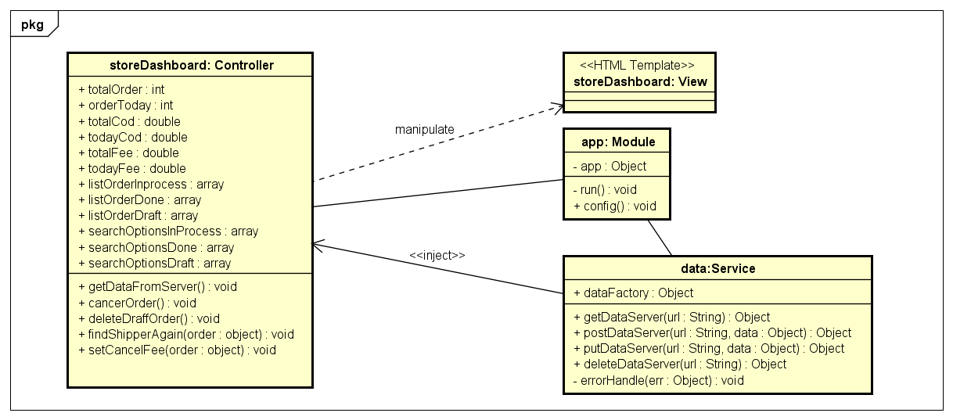***

******

***206\_Store’s Profile***

***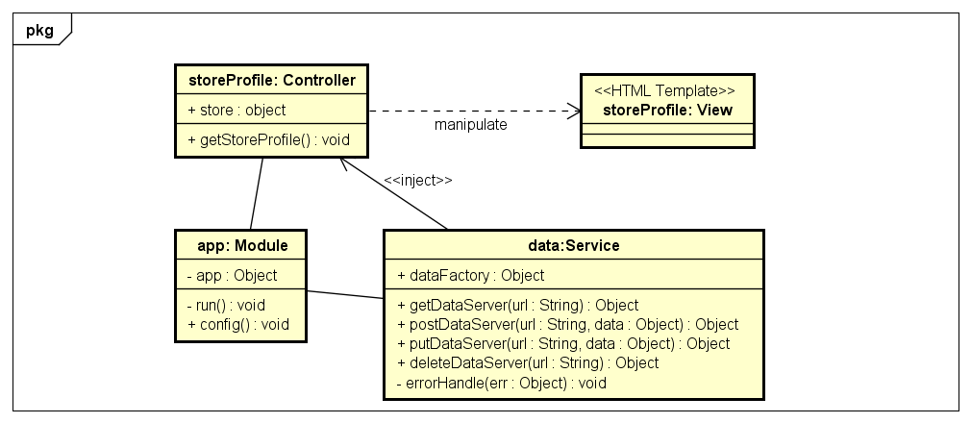***

***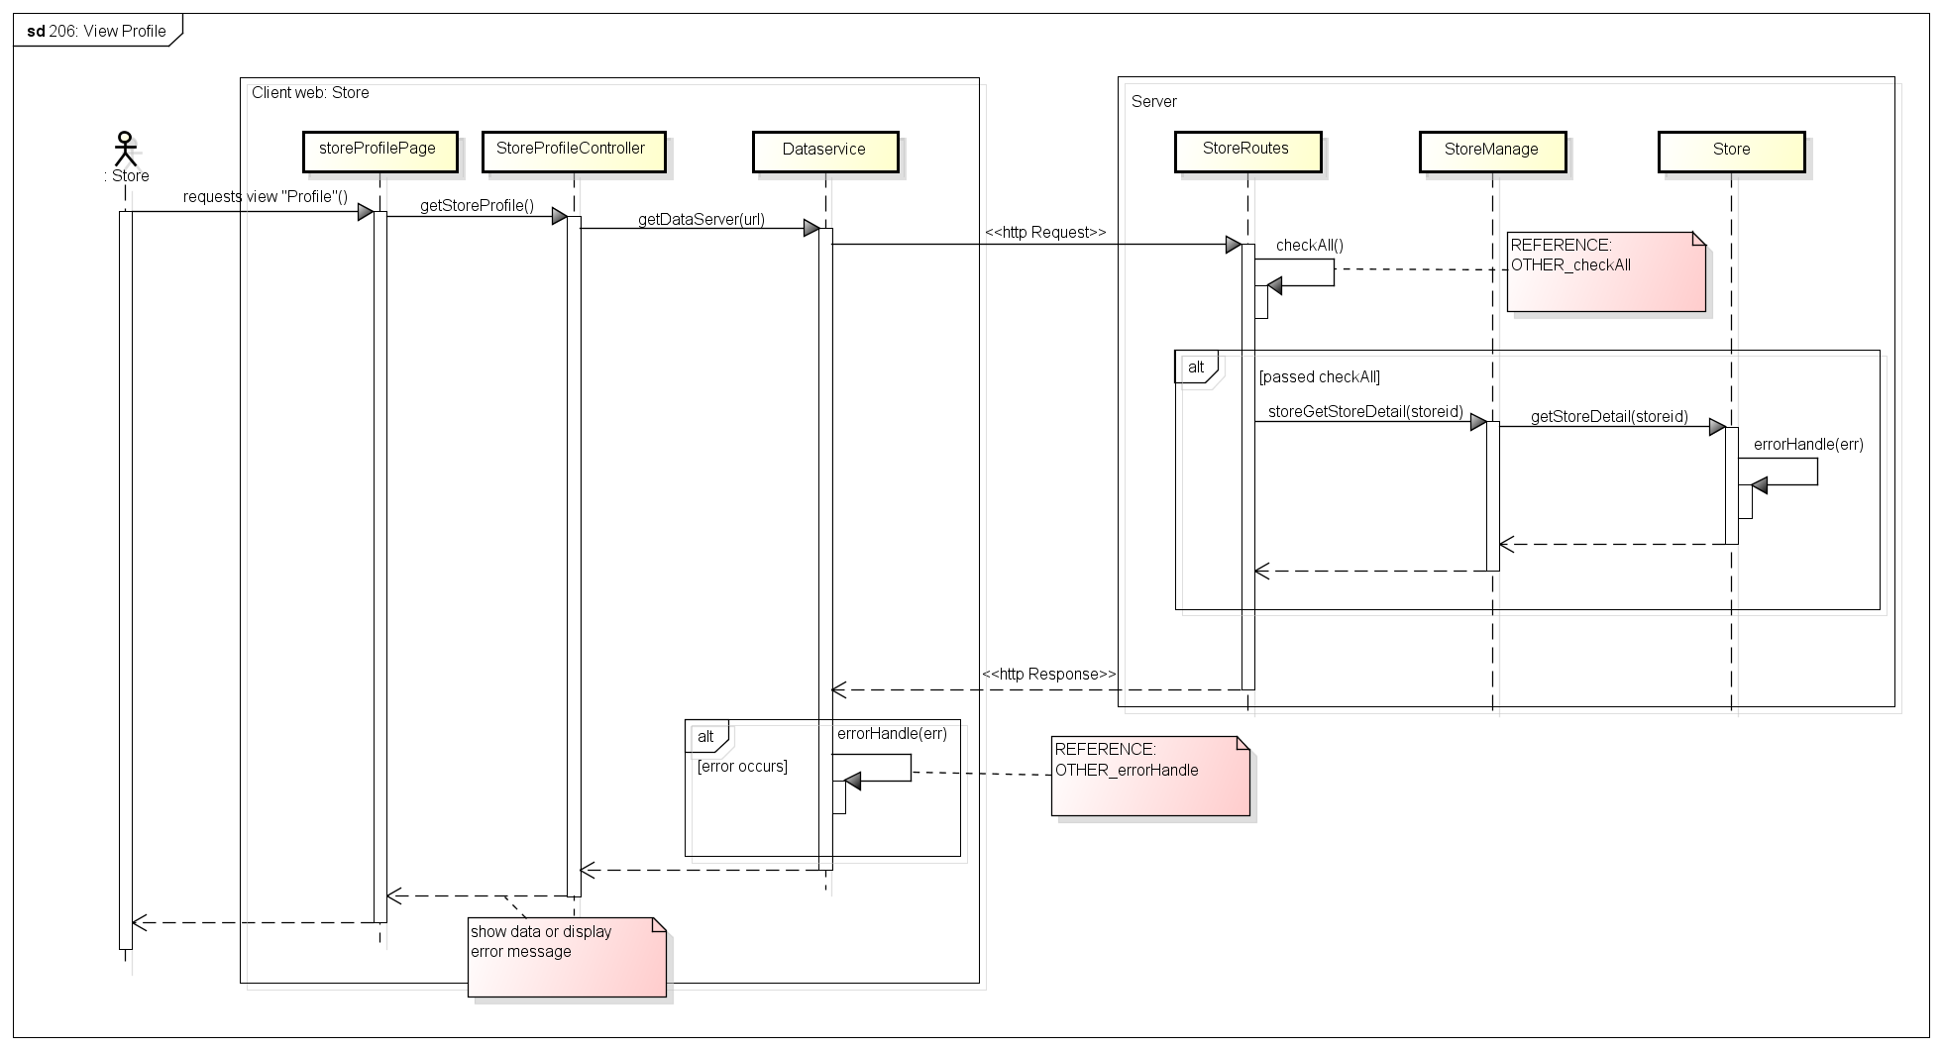***

***208\_Create Order***

***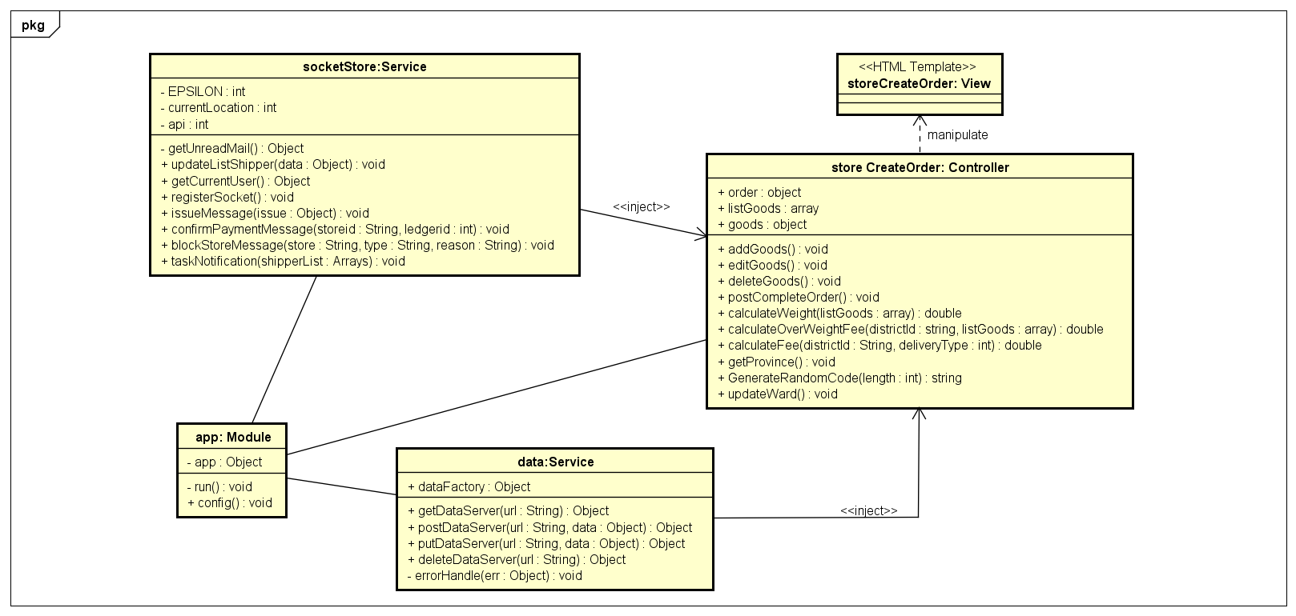***

***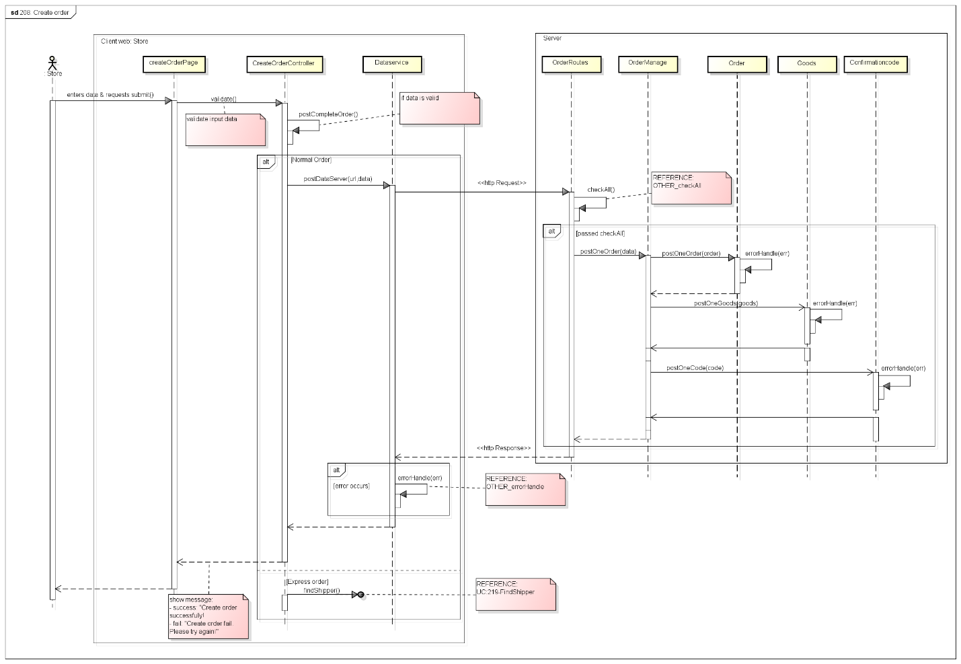***

***209\_ Find Shipper***

***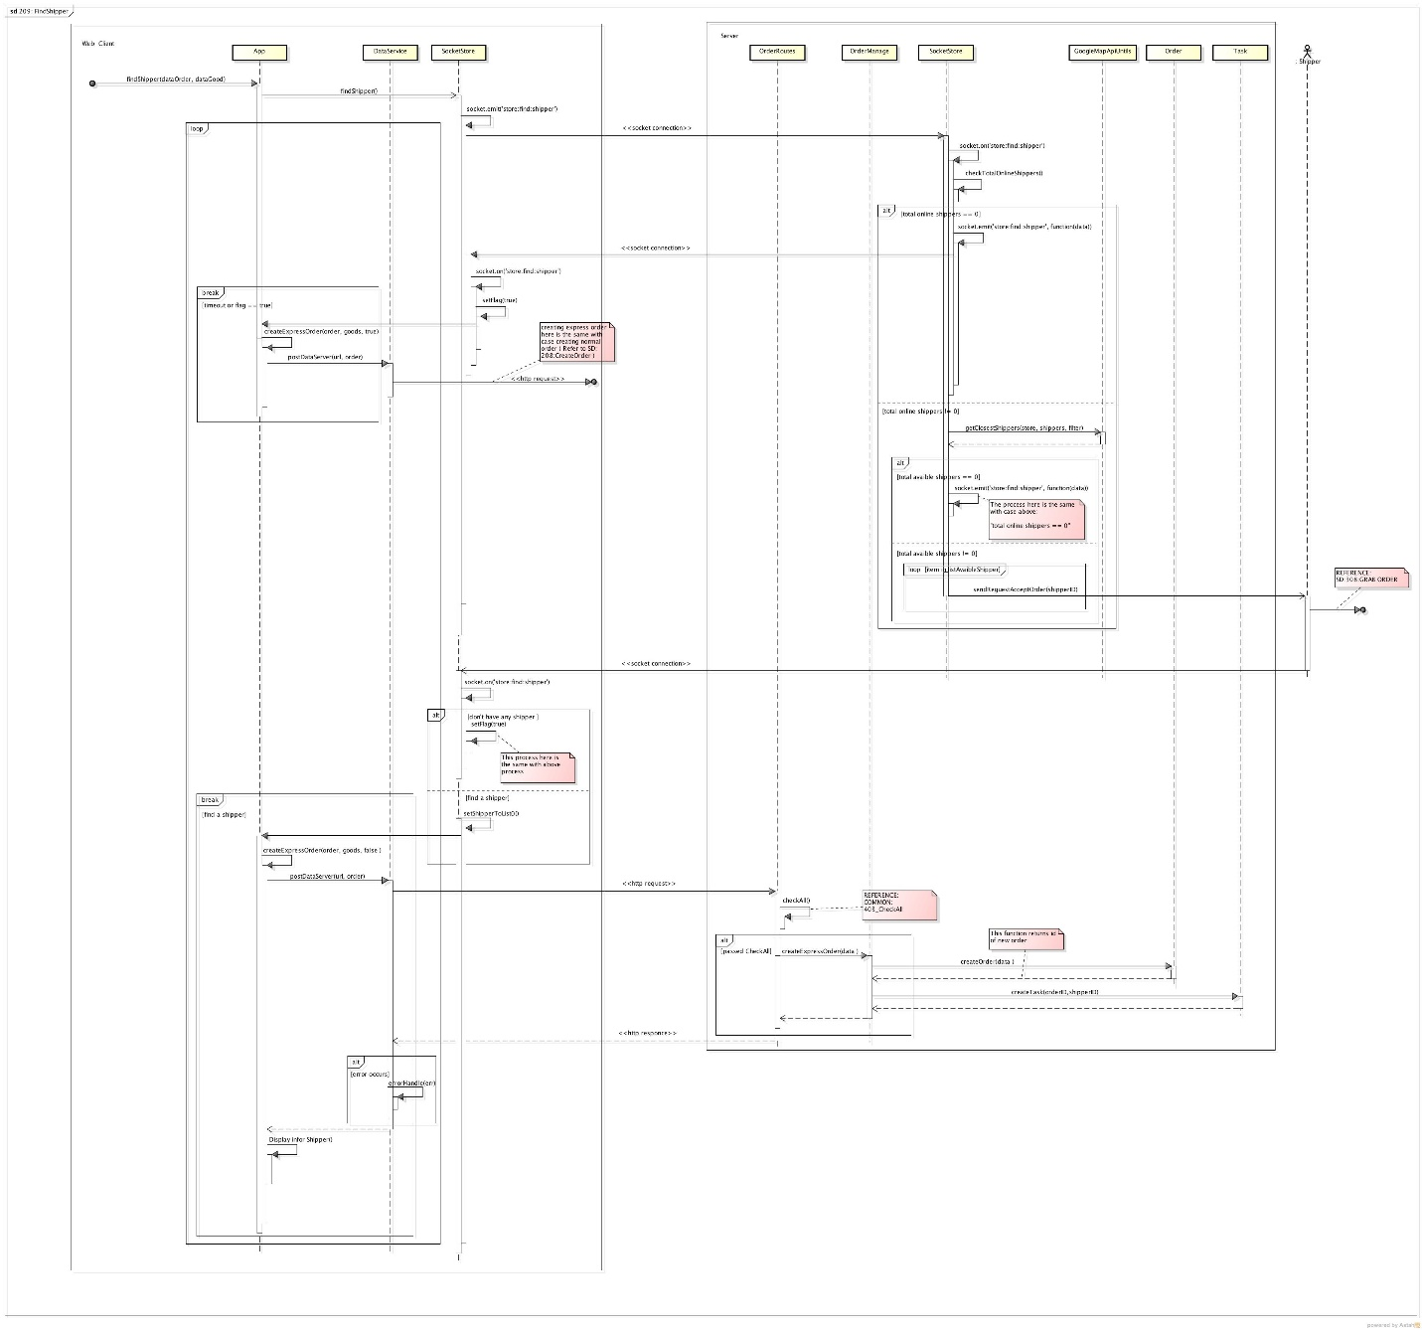***

***210\_ Edit order***

***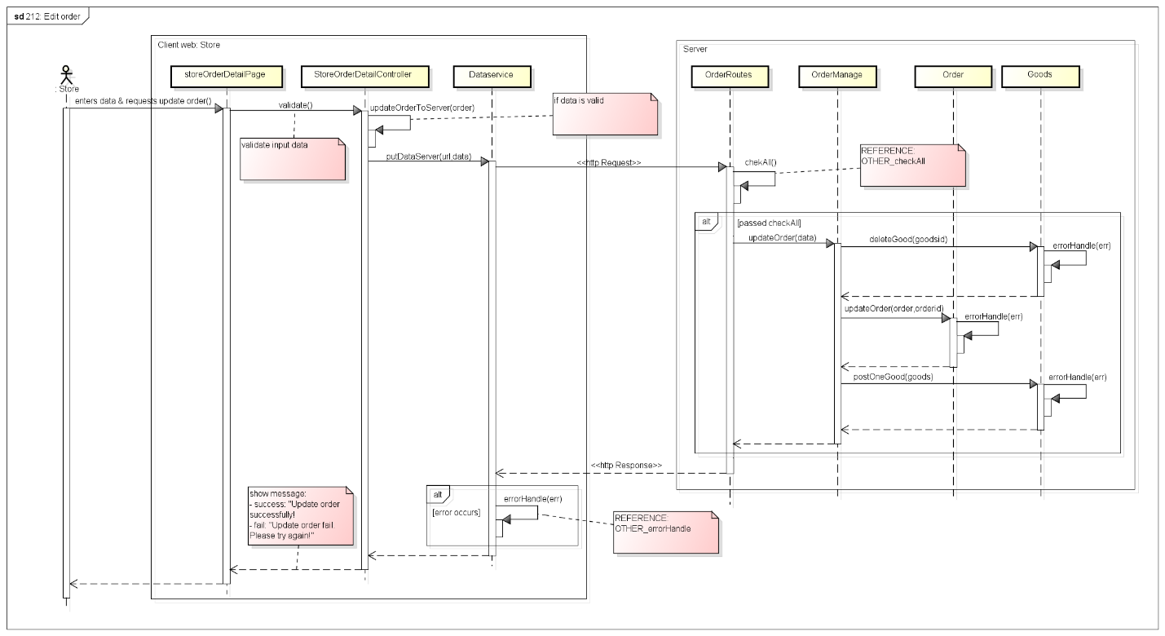***

***214\_Store View Order History***

***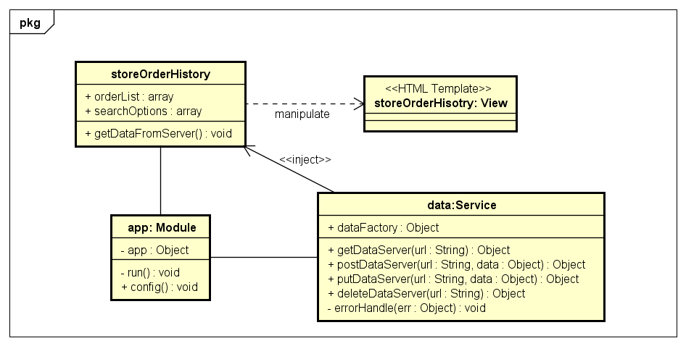***

***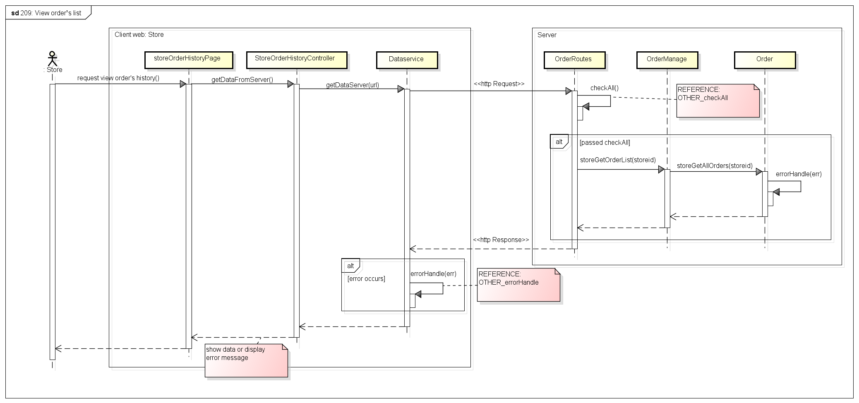***

***215\_ Search order***

***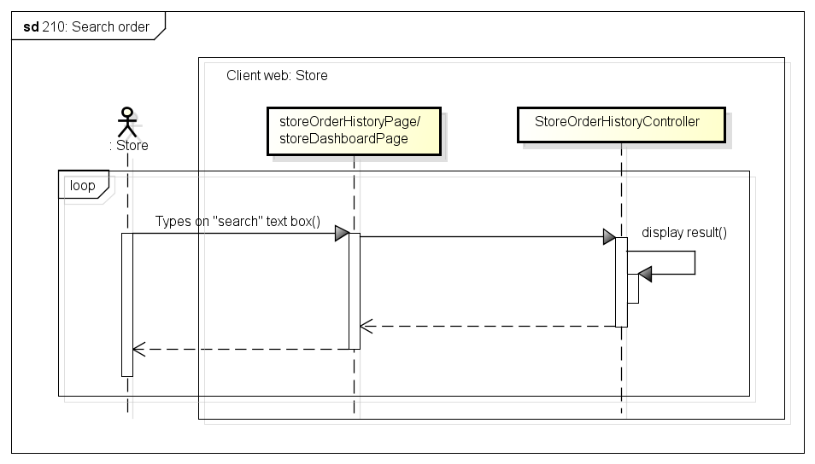***

***216\_ Cancel order***

***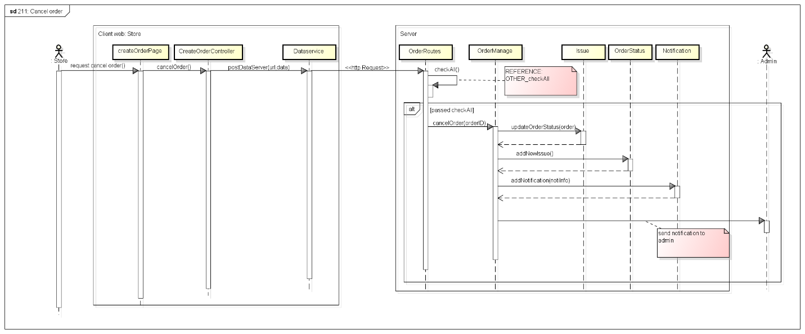***

***217\_Delete Order***

***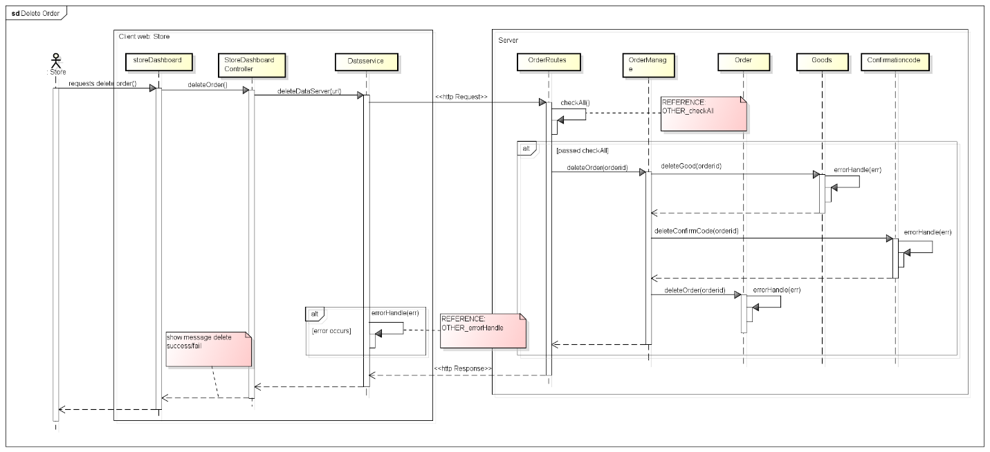***

***218\_Order Detail***

***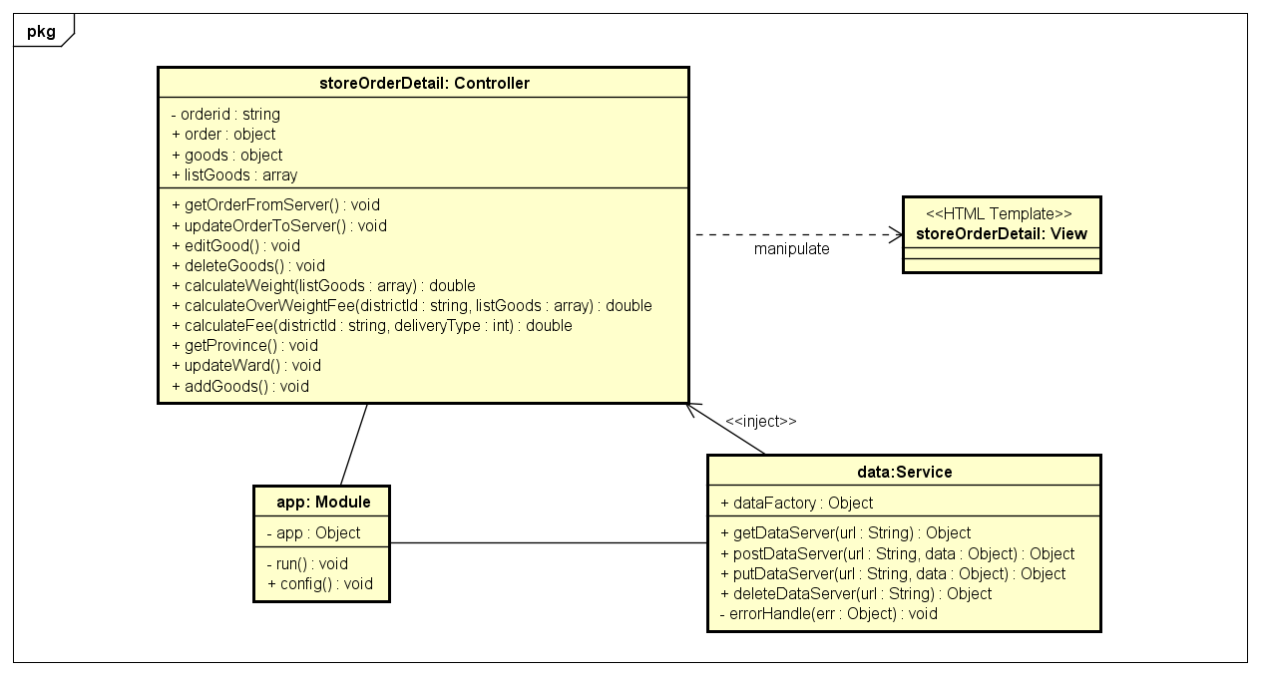***

***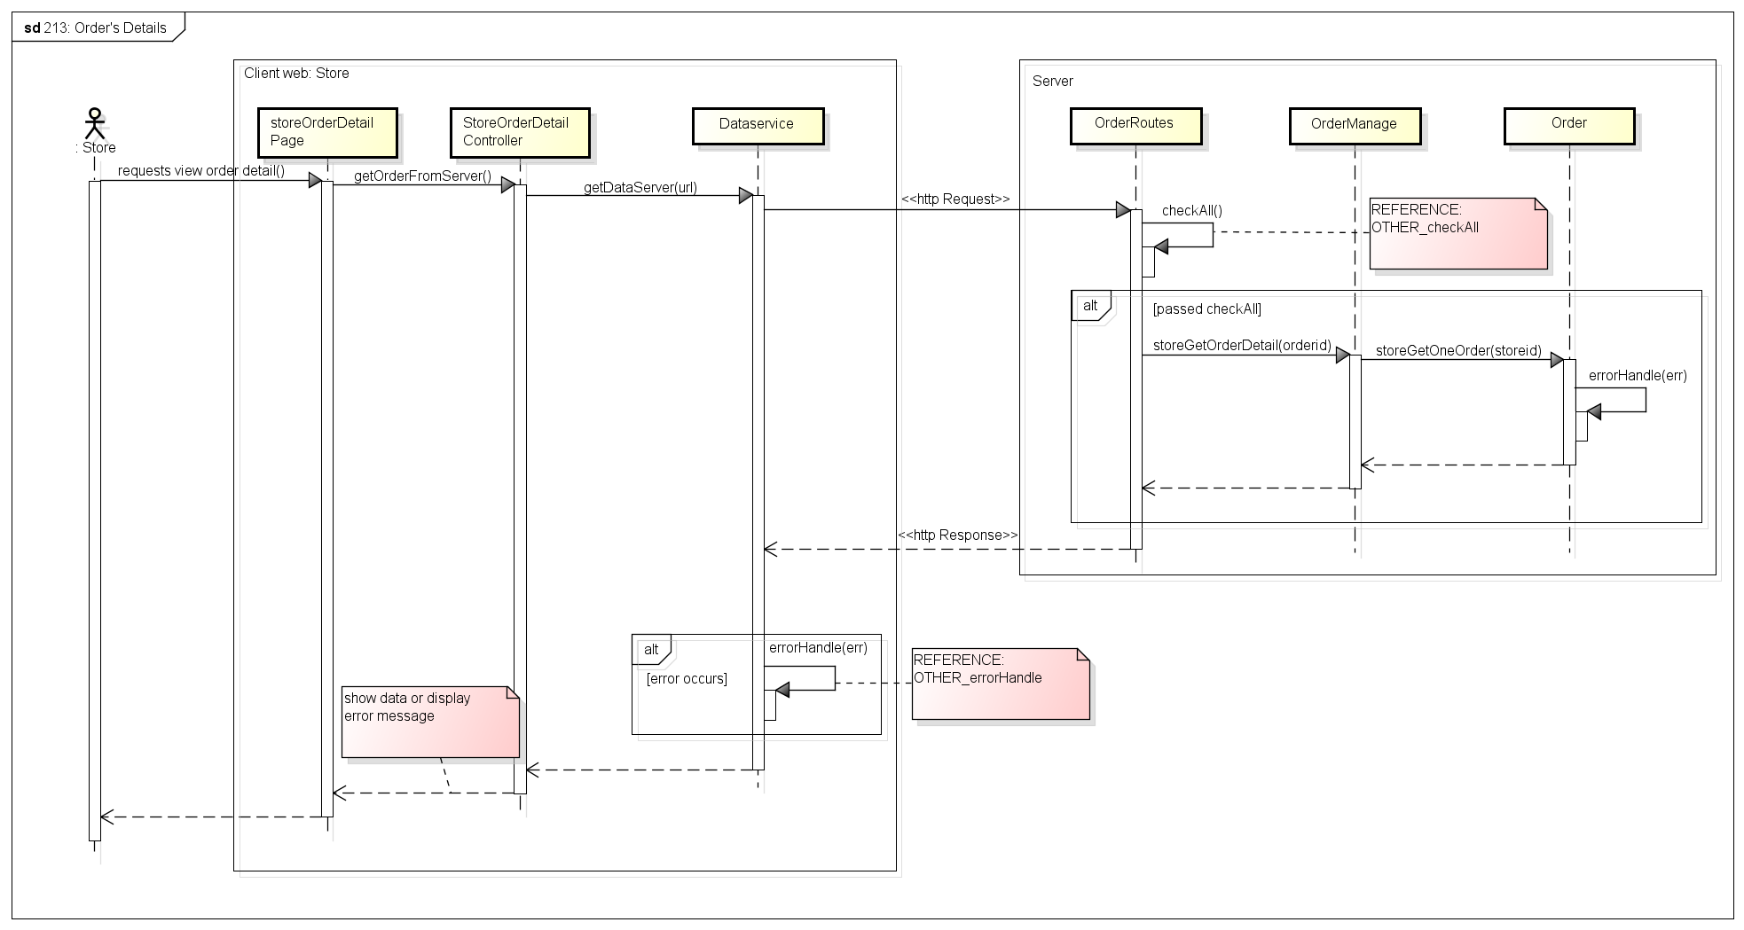***

***219\_Store Transaction History***

***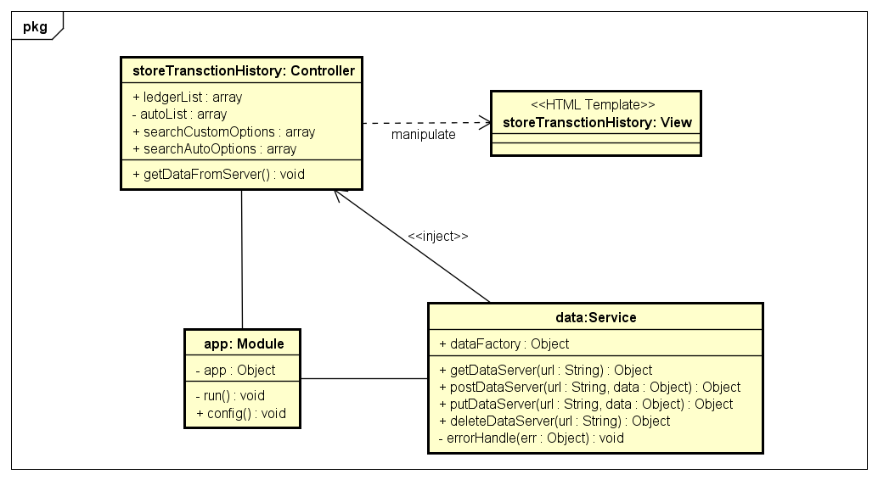***

***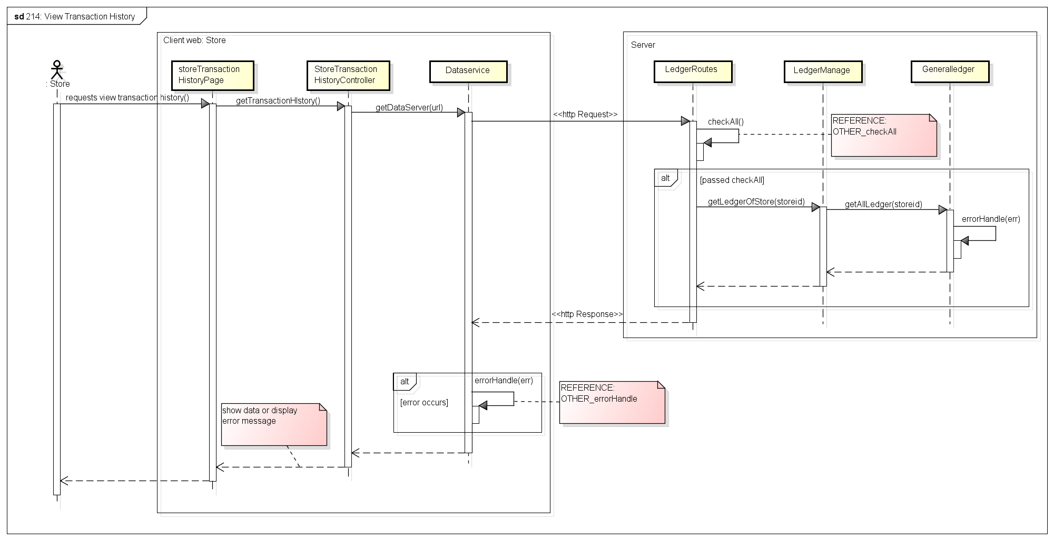***

***CLASS DESCRIPTION***

1. StoreDashboardController

Attributes

|  |  |  |  |  |
| --- | --- | --- | --- | --- |
| No | Attributes | Type | Default | Description |
|  | totalOrder | Int | N/A | Total not yet paid orders |
|  | orderToday | Int | N/A | Total orders on today |
|  | totalCod | Double | N/A | Total cash on delivery of not yet paid orders |
|  | todayCod | Double | N/A | Total cash on delivery on today |
|  | totalFee | Double | N/A | Total ship fee of not yet paid orders |
|  | todayFee | Double | N/A | Total ship fee on today |
|  | listOrderInprocess | Array | N/A | List of in process orders |
|  | listOrderDone | Array | N/A | List of completed orders |
|  | listOrderDraft | Array | N/A | List of draft orders |
|  | searchOptionsInProcess | Array | N/A | List of value for search in process order |
|  | searchOptionsDone | Array | N/A | List of value for search done order |
|  | searchOptionsDraft | Array | N/A | List of value for search draft order |

Methods

|  |  |  |  |  |
| --- | --- | --- | --- | --- |
| No | Methods | Parameters | Return | Description |
| 1 | getDataFromServer | N/A | N/A | Get data from server to display to screen |
| 2 | cancerOrder | N/A | N/A | Post request to cancel order of store to server and update screen |
| 3 | deleteDraffOrder | N/A | N/A | Post request to delete order of store to server and update screen |
| 4 | setCancelFee | Object | N/A | Calculate ship fee for order that store want to cancel |
| 5 | findShipperAgain | Object | N/A | Request to find a shipper |

1. StoreCreateOrderController

Attributes

|  |  |  |  |  |
| --- | --- | --- | --- | --- |
| No | Attributes | Type | Default | Description |
| 1 | order | Object | N/A | Information of new store |
| 2 | listGoods | Array | [] | List of new goods |
| 3 | goods | Object | N/A | Information of new goods |

Methods

|  |  |  |  |  |
| --- | --- | --- | --- | --- |
| No | Methods | Parameters | Return | Description |
| 1 | addGoods | N/A | N/A | Add a goods to order |
| 2 | editGoods | N/A | N/A | Edit information of a goods |
| 3 | deleteGoods | N/A | N/A | Delete a goods |
| 4 | postCompleteOrder | N/A | N/A | Post information of order to server to add to database |
| 5 | calculateWeight | Array | Double | Calculate total weight of goods on order |
| 6 | calculateOverWeightFee | String,Array | Double | Calculate over weight fee for order |
| 7 | calculateFee | String | N/A | Move all orders which get issue to task table |
| 8 | getProvince | N/A | N/A | Get list Province from server to fill to province drop down list |
| 9 | GenerateRandomCode | N/A | String | Generate code for authenticate shipper and end customer |
| 10 | updateWard() | N/A | N/A | Update ward drop down list when store change district. |

1. StoreOrderHistoryController

Attributes

|  |  |  |  |  |
| --- | --- | --- | --- | --- |
| No | Attributes | Type | Default | Description |
| 1 | orderList | Array | N/A | List of order |
| 2 | searchOptions | Array | N/A | List value for search orders |

Methods

|  |  |  |  |  |
| --- | --- | --- | --- | --- |
| No | Methods | Parameters | Return | Description |
| 1 | getDataFromServer | N/A | N/A | Get data from server to display to screen |

1. StoreProfileController

Attributes

|  |  |  |  |  |
| --- | --- | --- | --- | --- |
| No | Attributes | Type | Default | Description |
| 1 | store | Object | N/A | Information of store |

Methods

|  |  |  |  |  |
| --- | --- | --- | --- | --- |
| No | Methods | Parameters | Return | Description |
| 1 | getStoreProfile | N/A | N/A | Get data from server to display to screen |

1. OrderDetailController

Attributes

|  |  |  |  |  |
| --- | --- | --- | --- | --- |
| No | Attributes | Type | Default | Description |
| 1 | orderid | String | N/A | Id of Order get from previous screen |
| 2 | order | Object | N/A | Information of order |
| 3 | goods | Object | N/A | Information of goods |
| 4 | listGoods | Array | N/A | List of |

Methods

|  |  |  |  |  |
| --- | --- | --- | --- | --- |
| No | Methods | Parameters | Return | Description |
| 1 | getOrderFromServer | N/A | N/A | Get data from server and display to screen |
| 2 | updateOrderToServer | N/A | N/A | Post information of order to server to request update to database |
| 3 | editGoods | N/A | N/A | Edit information of a goods |
| 3 | addGoods | N/A | N/A | Add a goods to order |
| 4 | deleteGoods | N/A | N/A | Delete a goods |
| 5 | calculateWeight | Array | Double | Calculate total weight of goods on order |
| 6 | calculateOverWeightFee | String,Array | Double | Calculate over weight fee for order |
| 7 | calculateFee | String | N/A | Move all orders which get issue to task table |
| 8 | getProvince | N/A | N/A | Get list Province from server to fill to province drop down list |

1. StoreTransctionController

Attributes

|  |  |  |  |  |
| --- | --- | --- | --- | --- |
| No | Attributes | Type | Default | Description |
| 1 | ledgerList | Array | [] | List of all transactions was added by admin |
| 2 | searchCustomOptions | Array | [] | List of type for search custom transaction |
| 3 | autoList | Array | [] | List of all transactions was added automatically by sytem |
| 4 | searchAutoOptions | Array | [] | List of type for search auto transaction |

Methods

|  |  |  |  |  |
| --- | --- | --- | --- | --- |
| No | Methods | Parameters | Return | Description |
| 1 | getDataFromServer | N/A | N/A | Get data from server to display to screen |

1. WEB APPLICATION FOR ADMIN

***105\_Admin Add Store***

***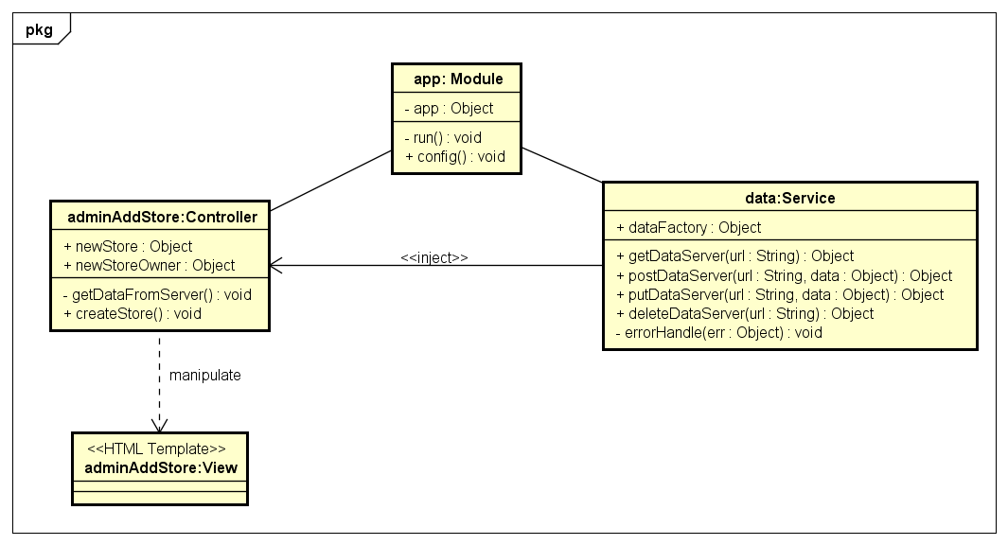***

***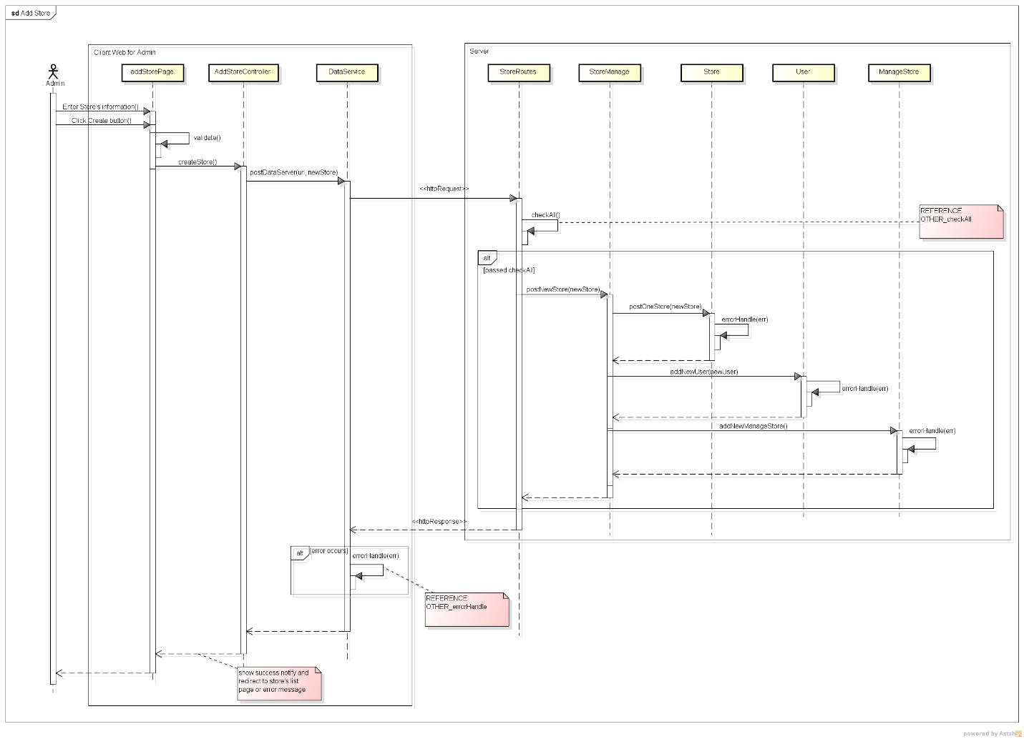***

***107\_Admin View Store List***

***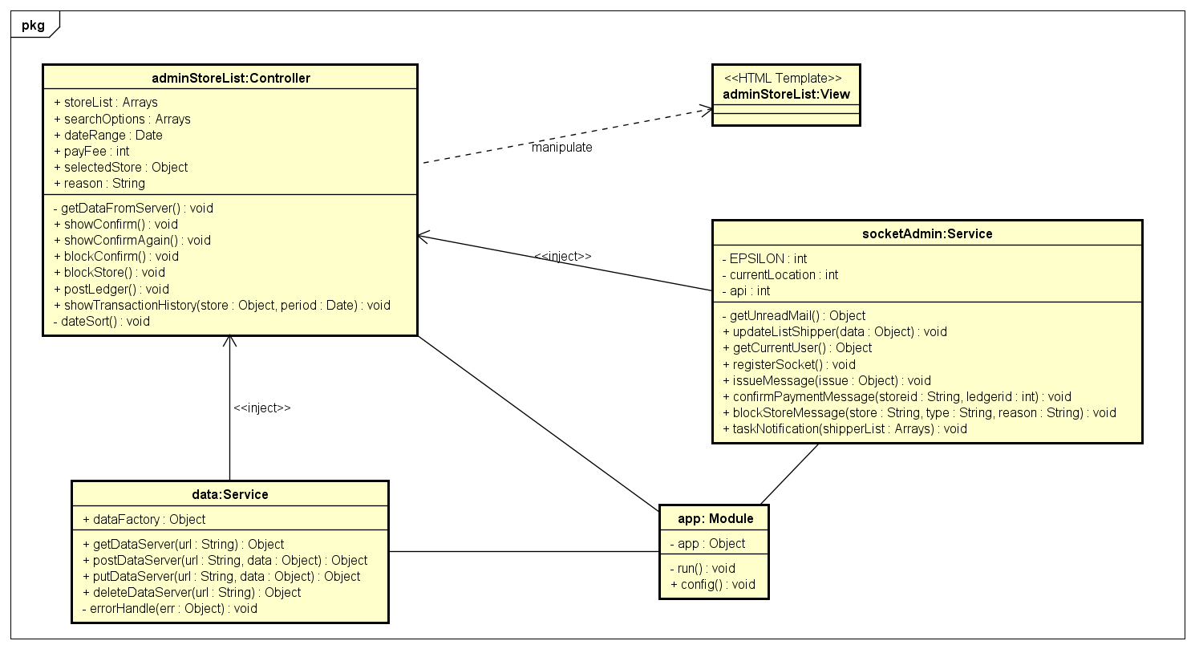***

***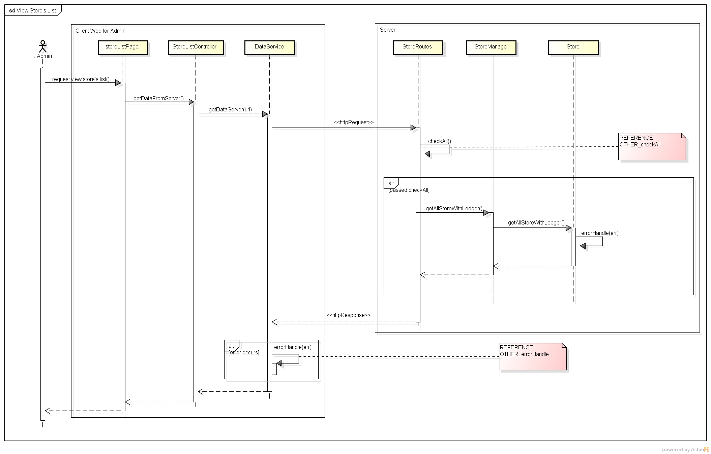***

***108\_Block\_Unblock Store***

***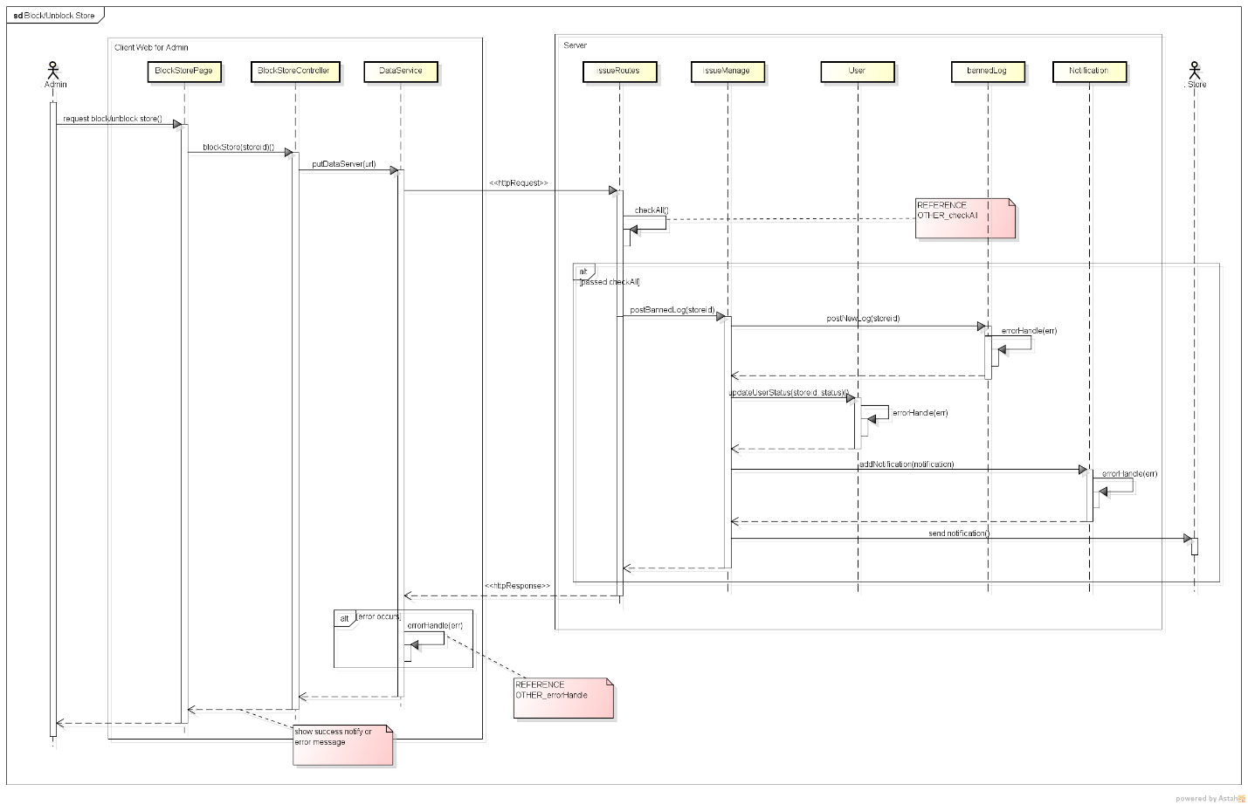***

***109\_Store Detail***

***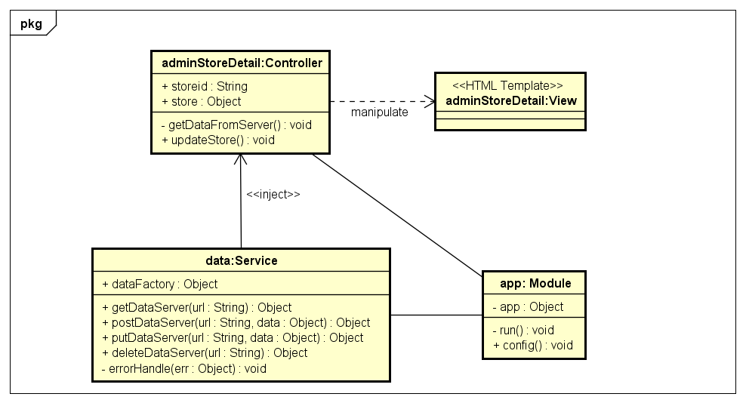***

***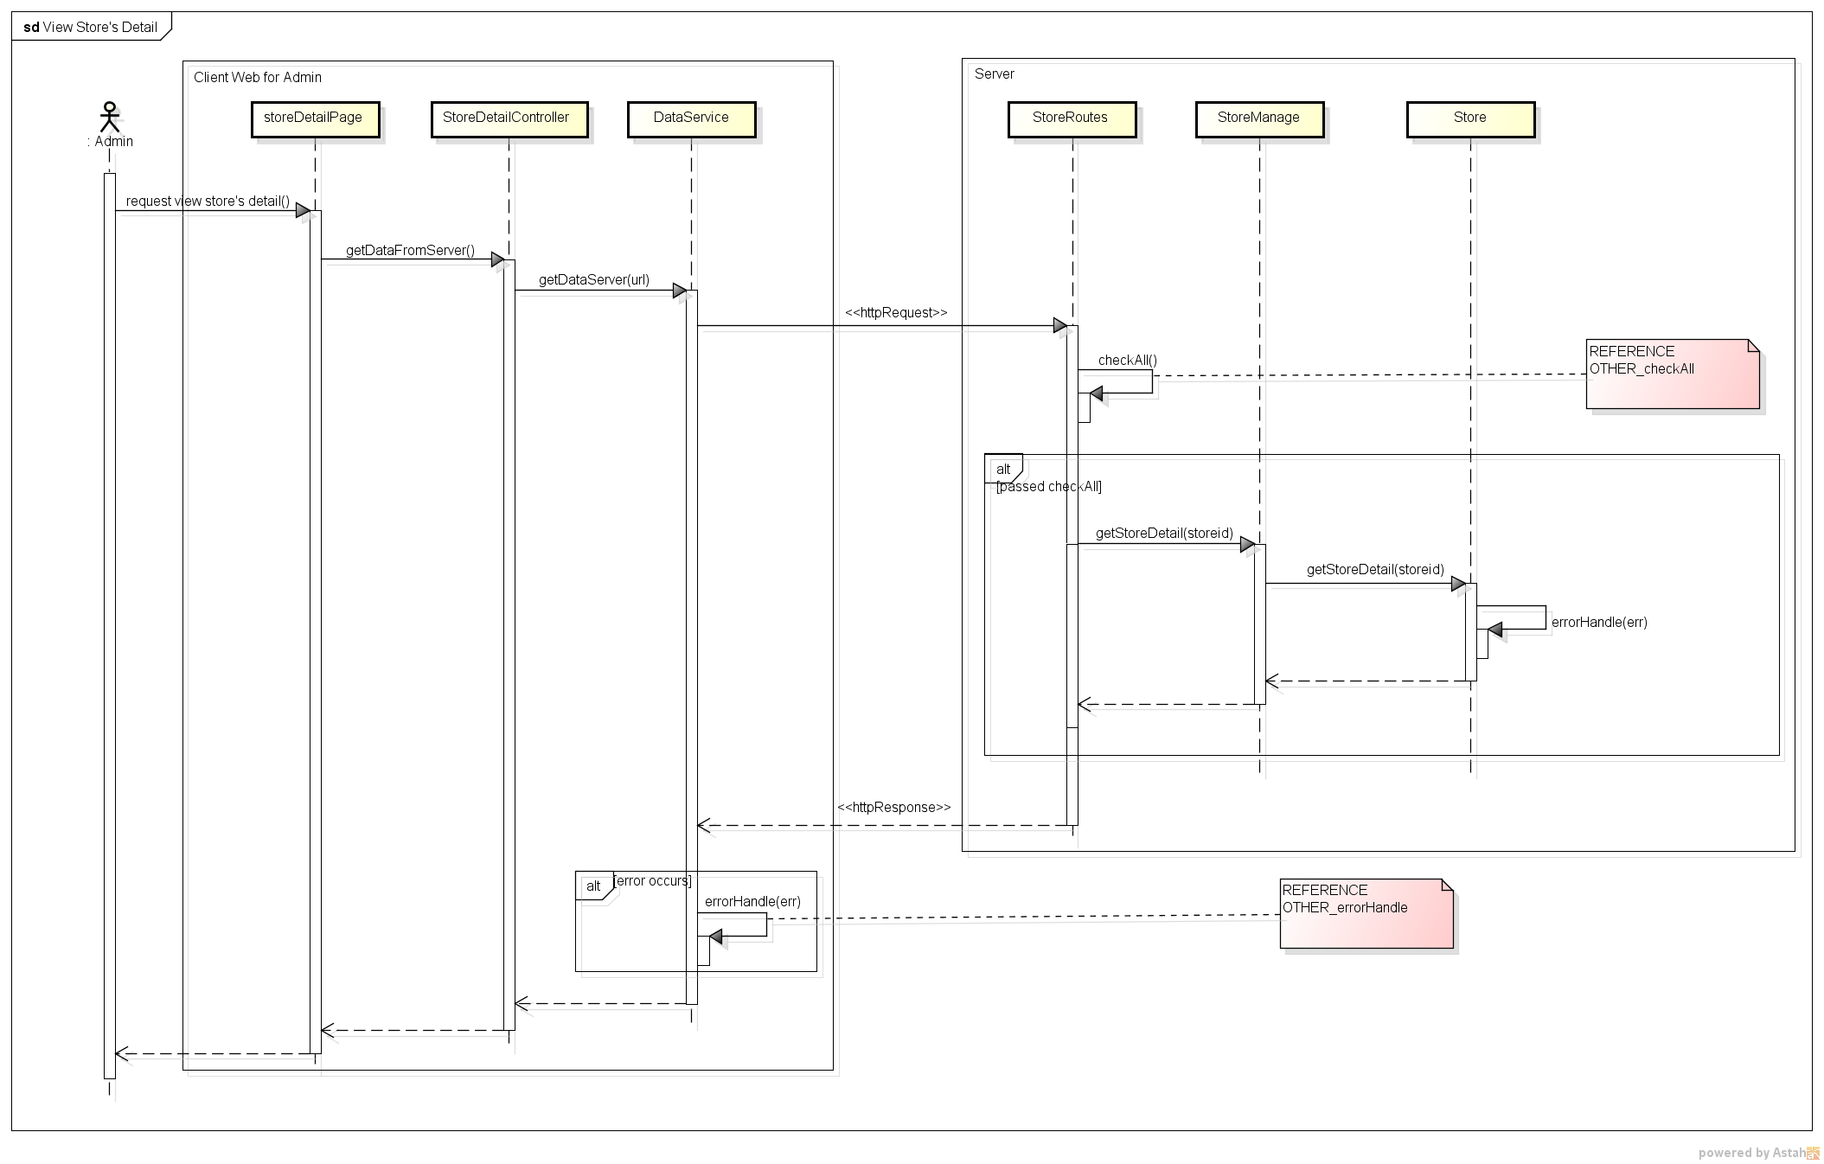***

***111\_Confirm Payment***

***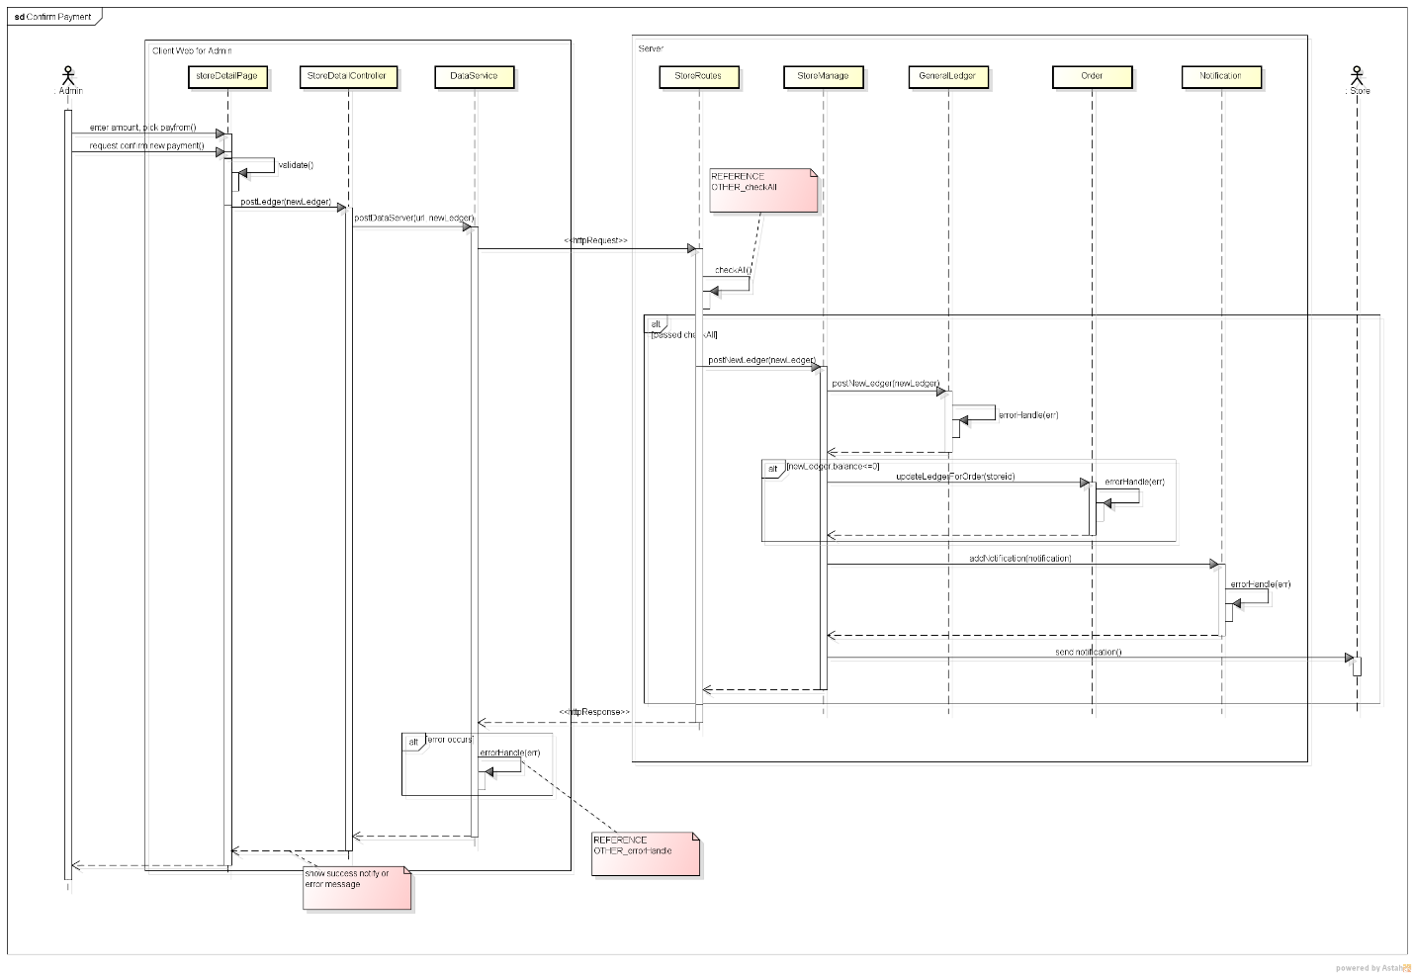***

***112\_Admin Transaction History***

***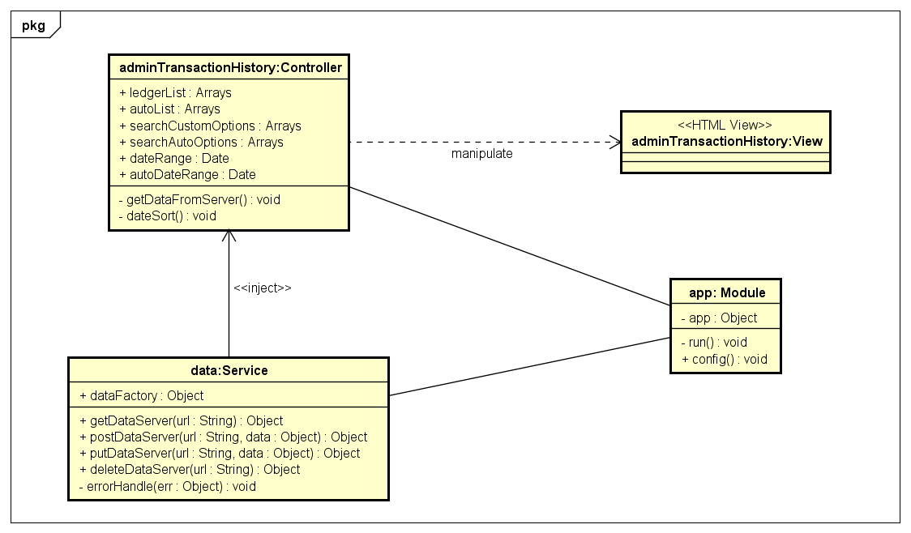***

***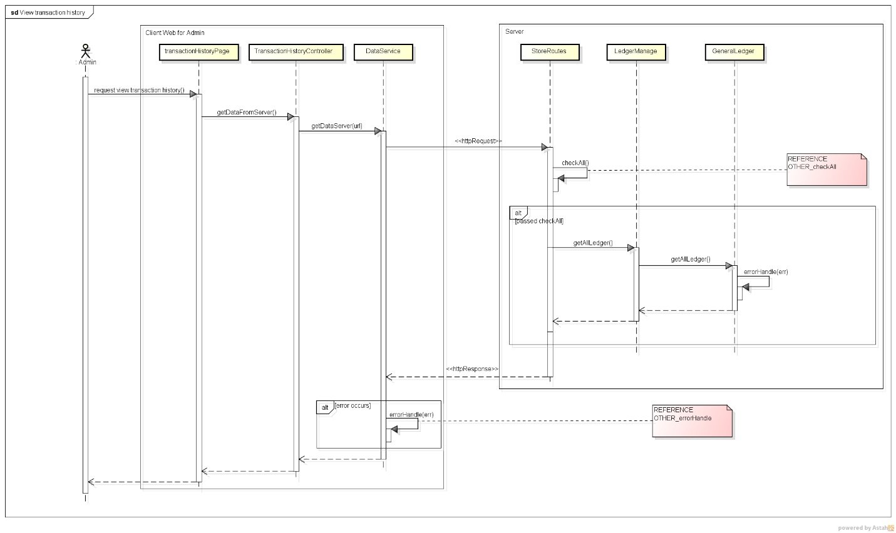***

***113\_Add Shipper***

***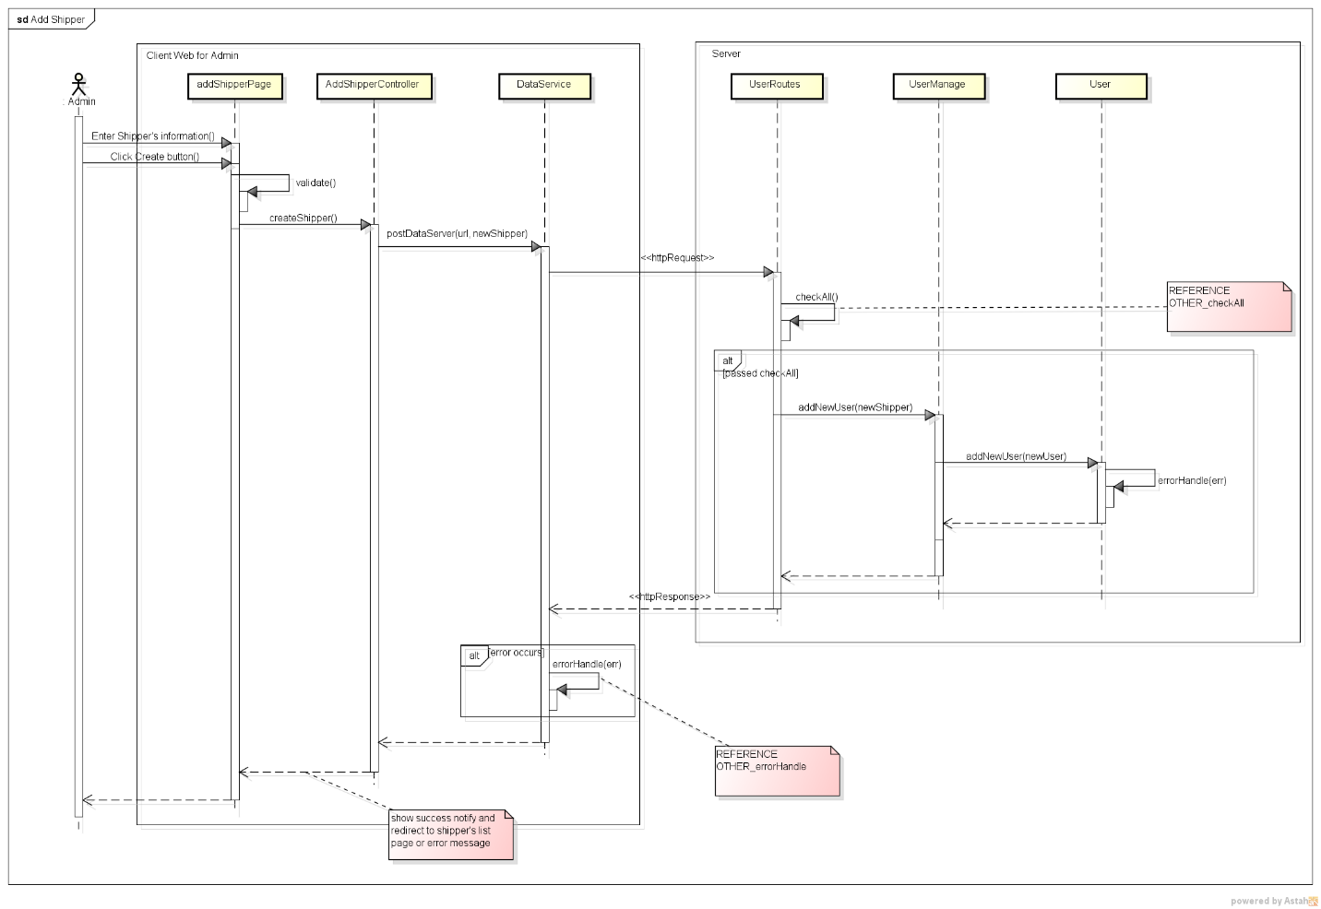***

***114\_View Shipper List***

***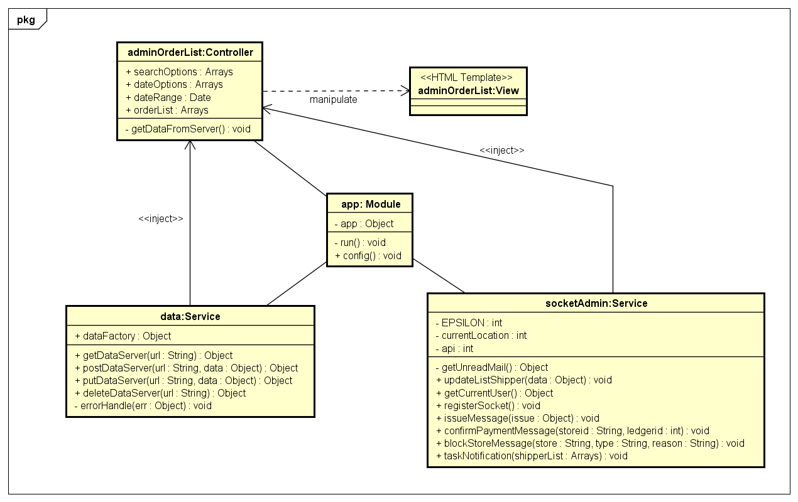***

***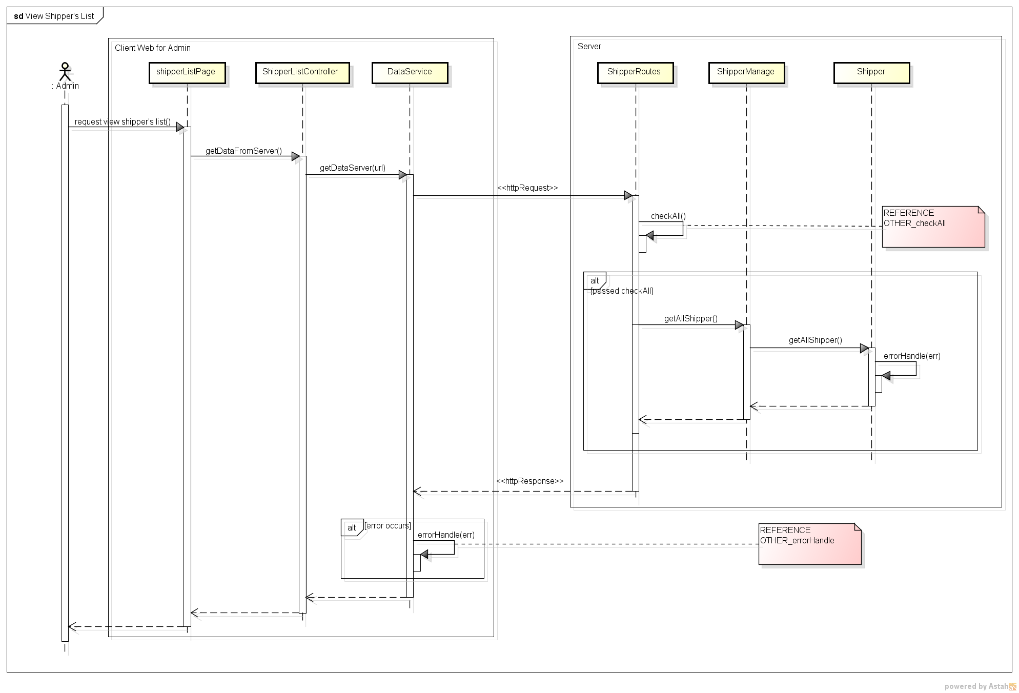***

***115\_Admin View Order List***

***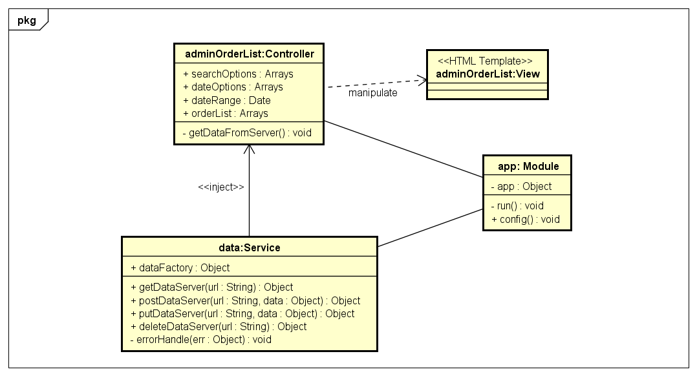***

***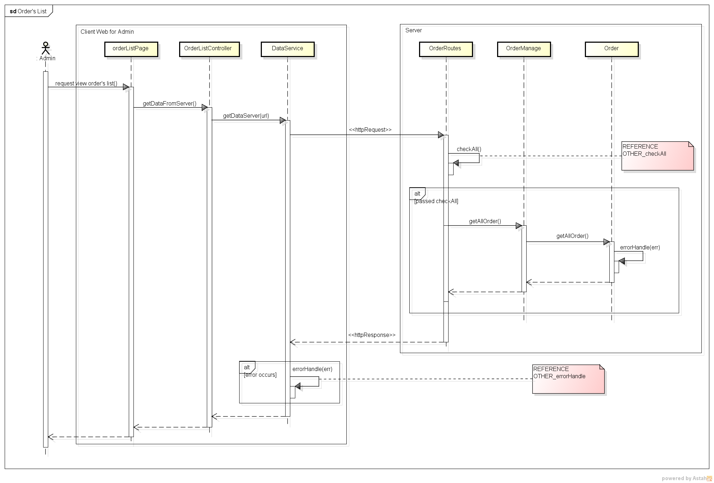***

***118\_View User's Detail*** ***118\_View User's Detail***

***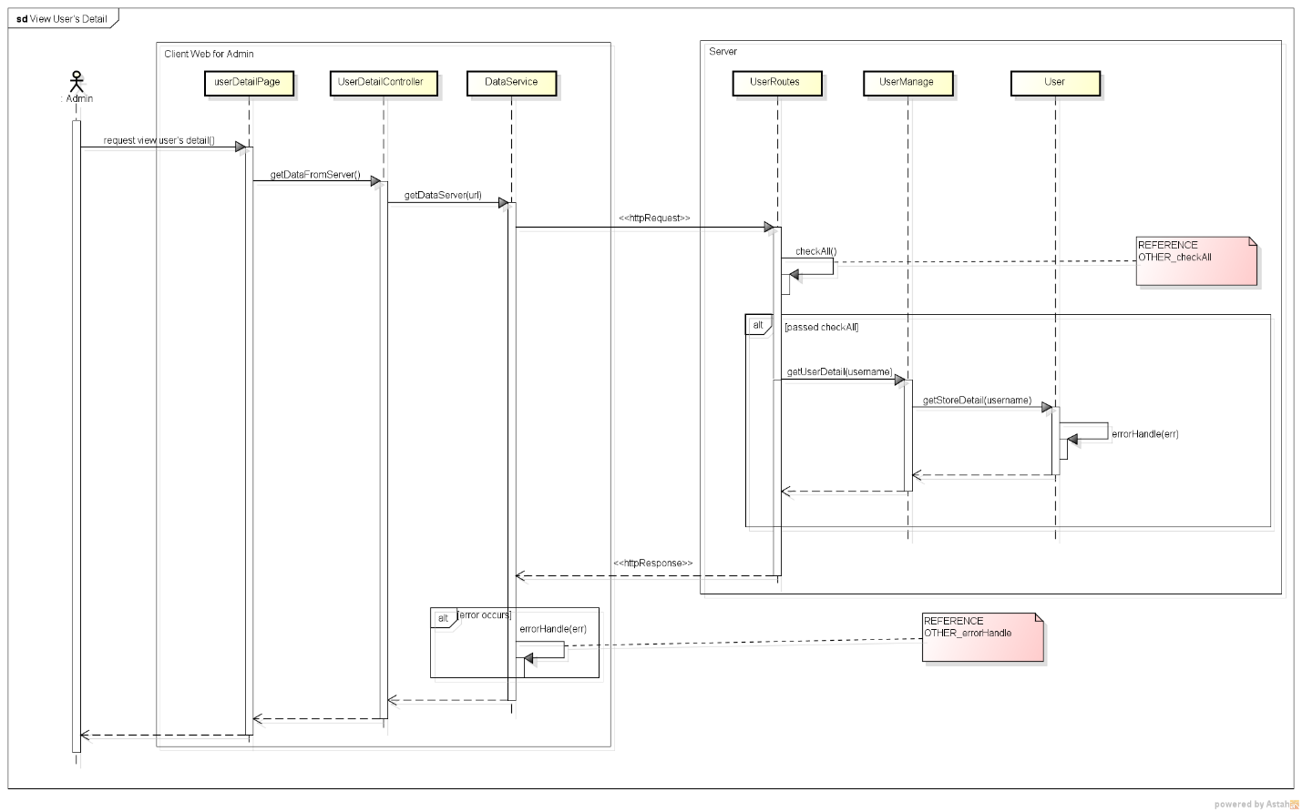***

***120\_Admin User Detail***

***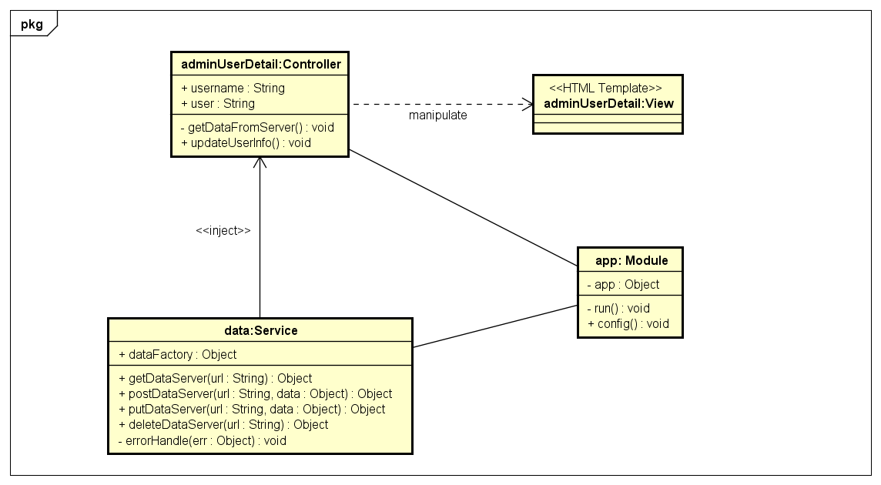***

***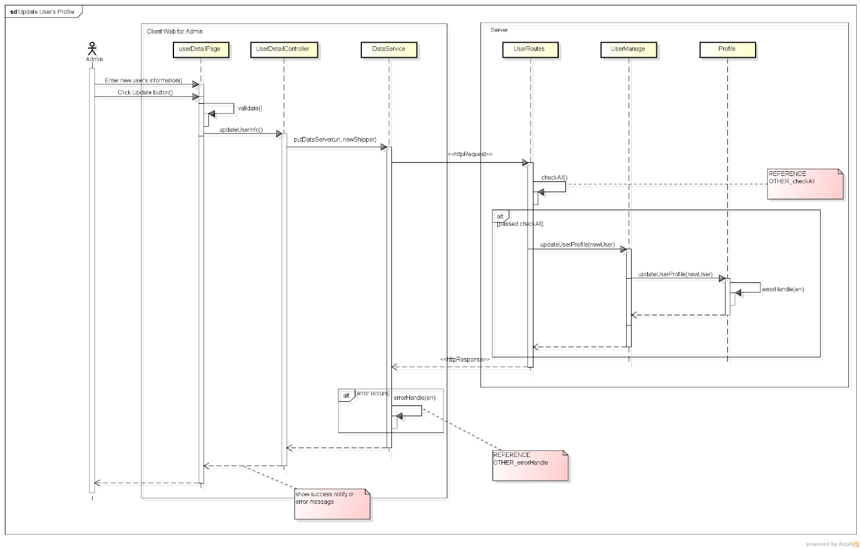***

***121\_Update Store's Information***

***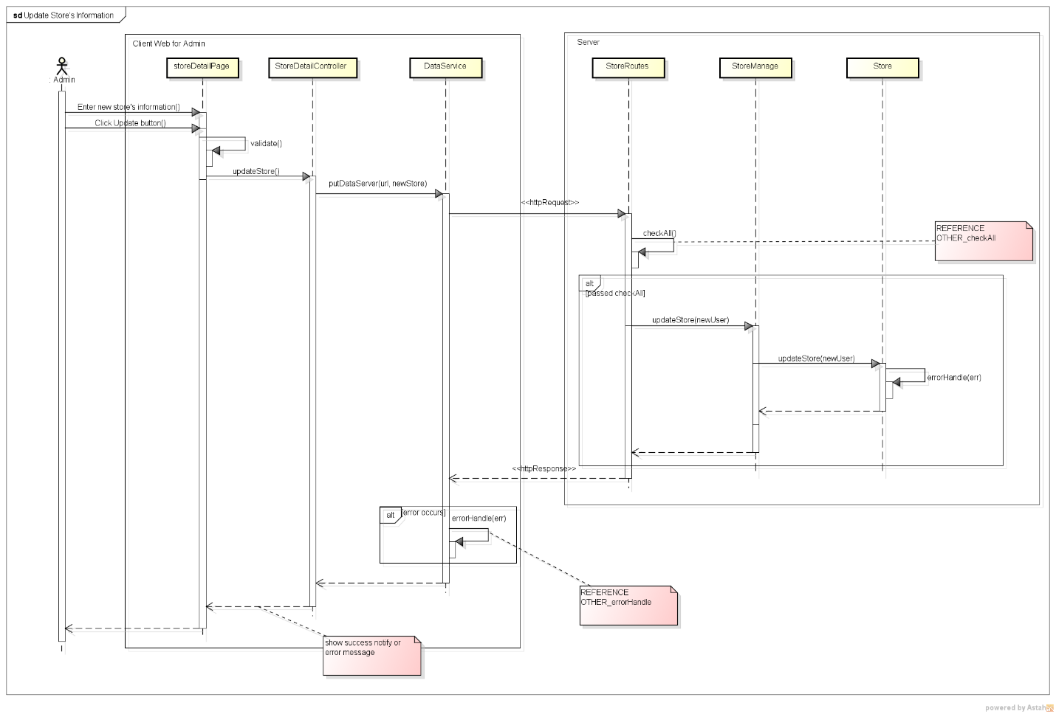***

***124\_Admin Assign Task***

***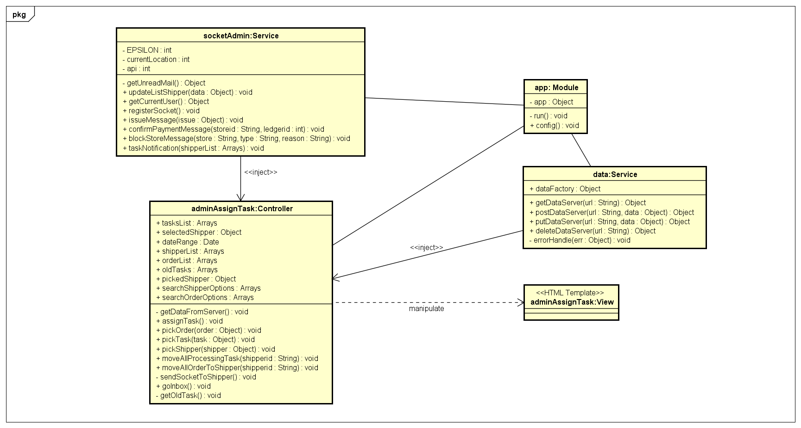***

***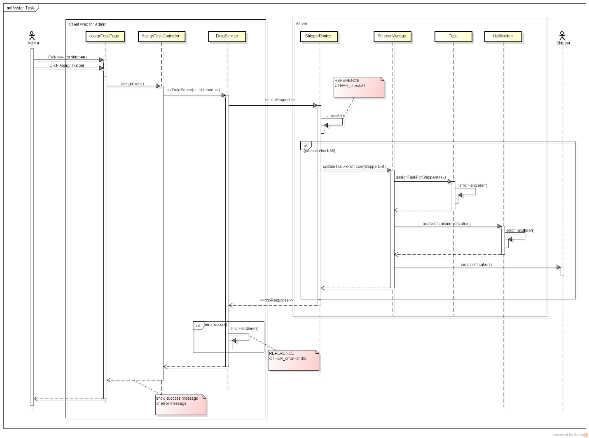***

***125\_Admin Dashboard***

***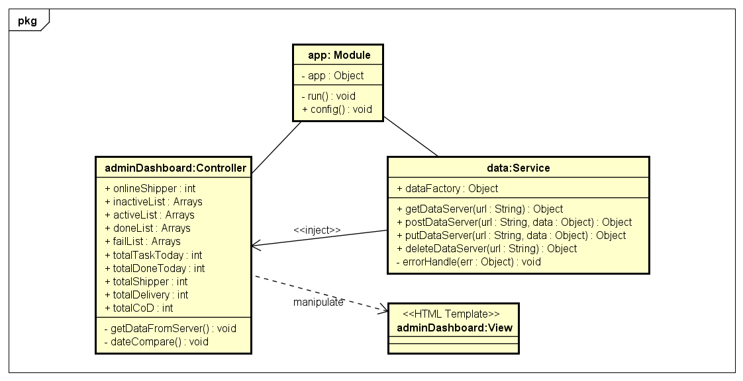***

***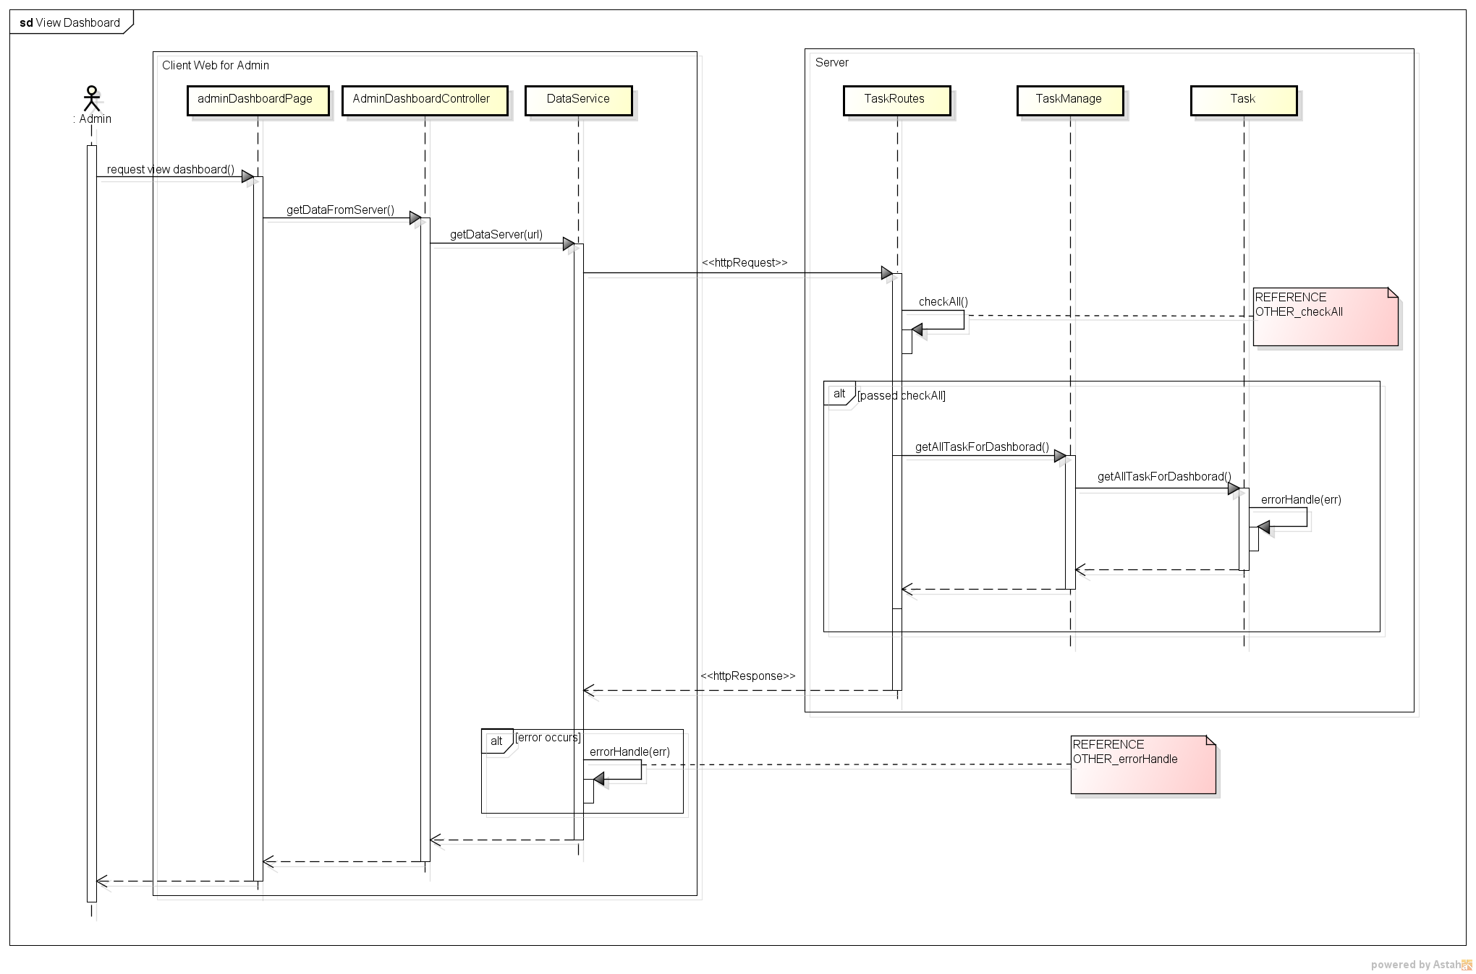***

***126\_View IssueBox***

***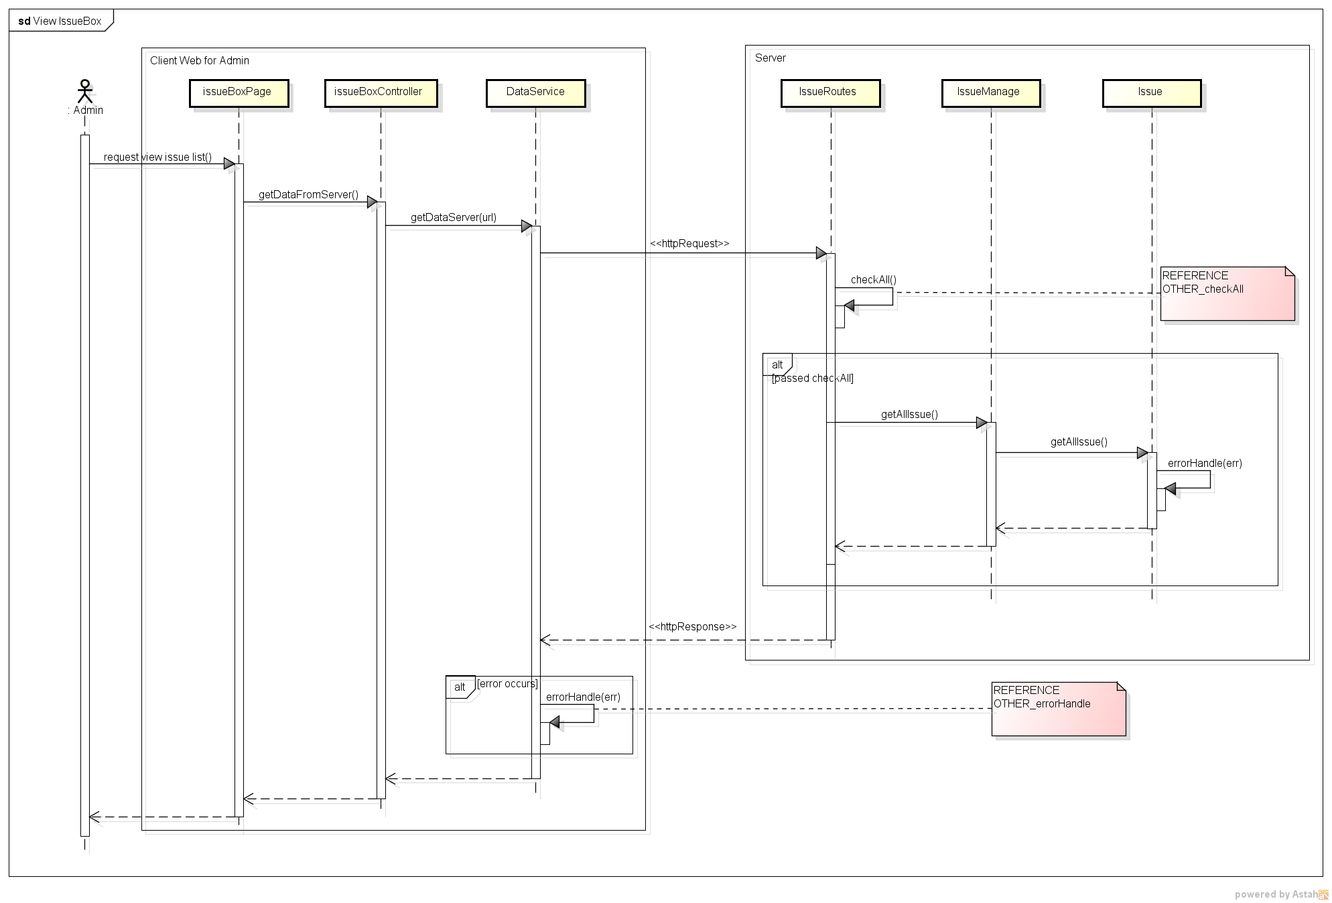***

***127\_Admin Resolve Issue***

***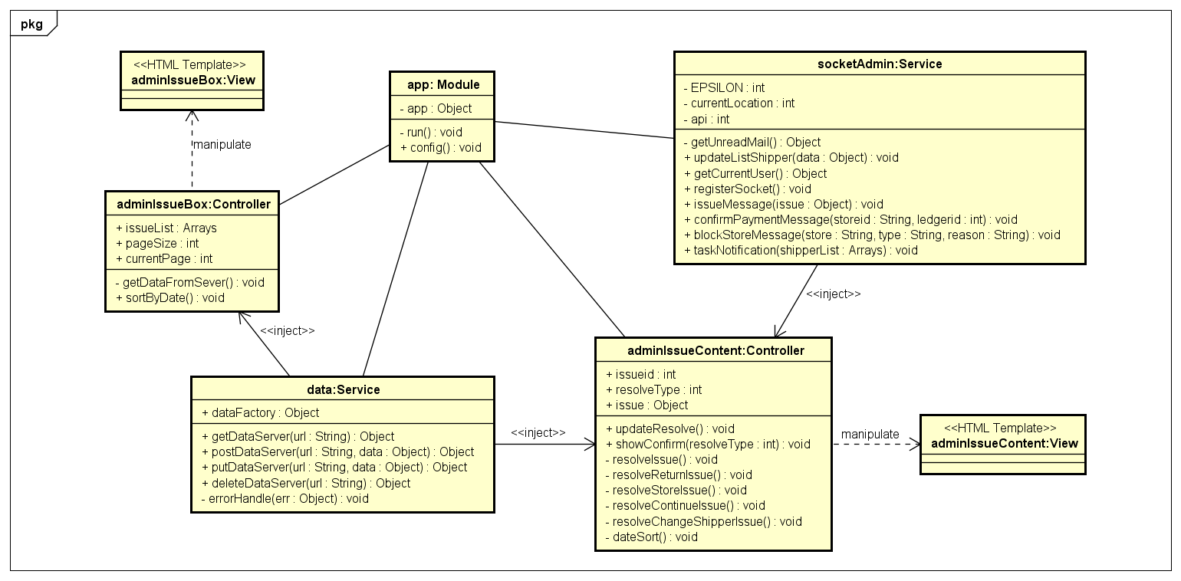***

***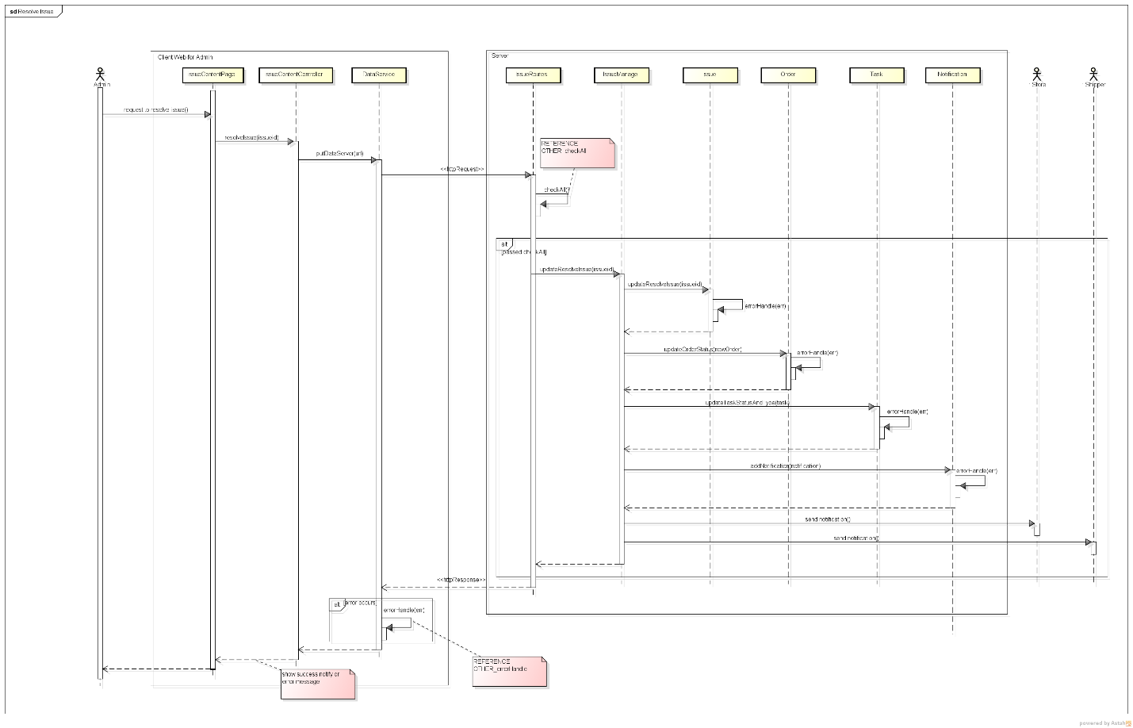***

***128\_Admin Task List***

***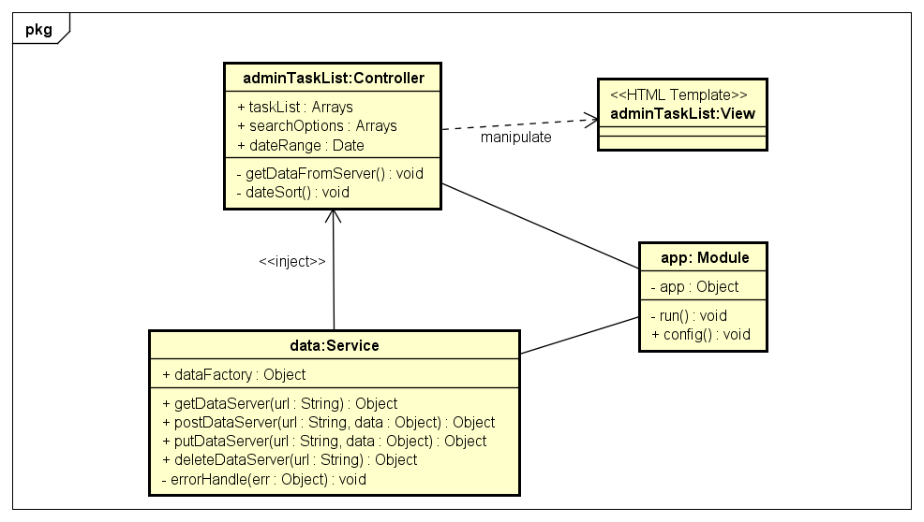***

***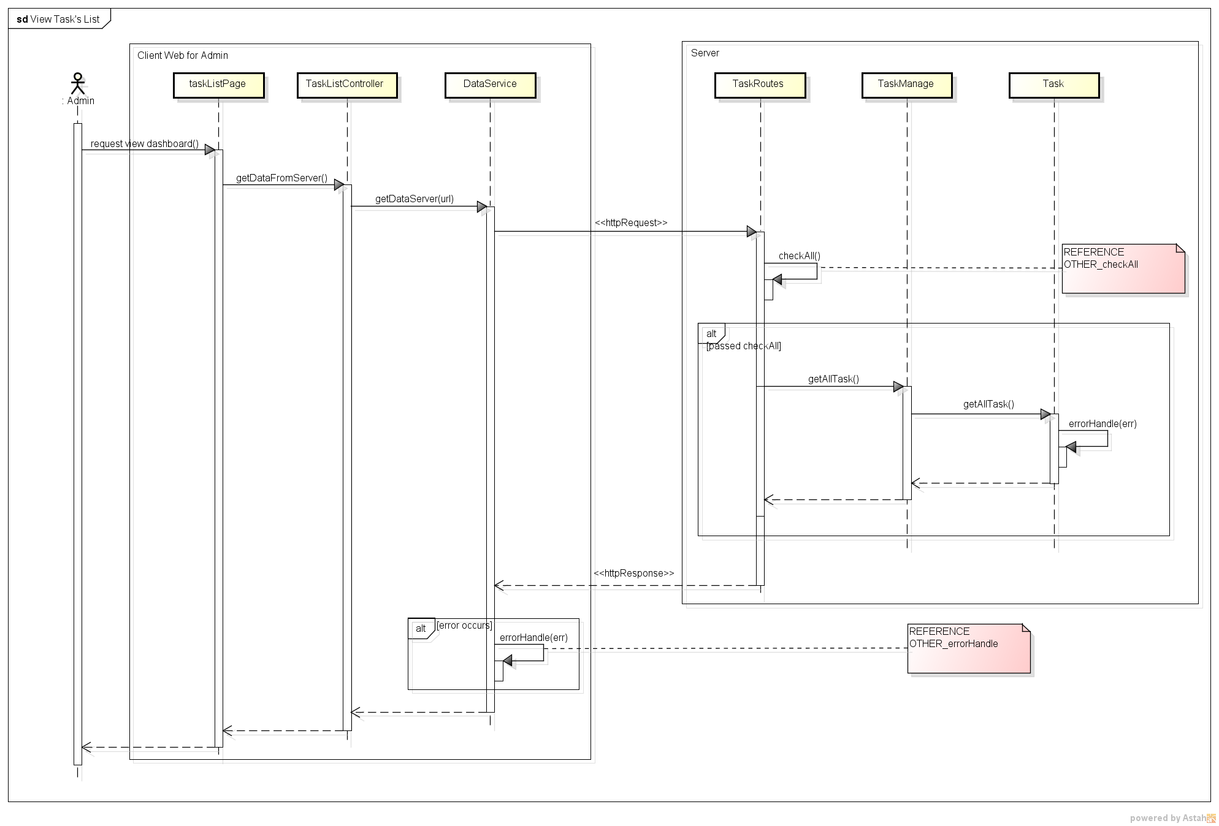***

***CLASS DESCRIPTON***

1. AdminAddStoreController

Attributes

|  |  |  |  |  |
| --- | --- | --- | --- | --- |
| No | Attributes | Type | Default | Description |
|  | newStore | Object | N/A | Information of new Store |
|  | newStoreOwner | Object | N/A | Information of new Store Owner |

Methods

|  |  |  |  |  |
| --- | --- | --- | --- | --- |
| No | Methods | Parameters | Return | Description |
| 1 | getDataFromServer | N/A | N/A | Get data from server to display to screen |
| 2 | createStore | N/A | N/A | Post adding store request to server |

1. AdminAssignTaskController

Attributes

|  |  |  |  |  |
| --- | --- | --- | --- | --- |
| No | Attributes | Type | Default | Description |
| 1 | tasksList | Array | [] | All tasks that can be assigned for other shipper of selected shipper |
| 2 | shipperList | Array | [] | List of all shipper |
| 3 | orderList | Array | [] | List of all orders that can be assigned for shipper |
| 4 | oldTasks | Array | [] | List tasks of shipper before assign |
| 5 | pickedShipper | Object | Null | Shipper is selected |
| 6 | searchShipperOptions | Array | [] | Options in drop-downlist for search shipper |

Methods

|  |  |  |  |  |
| --- | --- | --- | --- | --- |
| No | Methods | Parameters | Return | Description |
| 1 | getDataFromServer | N/A | N/A | Get data from server to display to screen |
| 2 | assignTask | N/A | N/A | Send update shipper task request to server |
| 3 | pickOrder | Object | N/A | If user pick an order of order table, order will move to task table |
| 4 | pickTask | Object | N/A | If user pick an order of task table, order will move to order table |
| 5 | pickShipper | Object | N/A | After user select shipper, all tasks that can assigned for other shipper will be displayed in task table |
| 6 | moveAllProcessingTask | String | N/A | Move all orders in task table to order table |
| 7 | moveAllOrderToShipper | String | N/A | Move all orders which get issue to task table |
| 8 | sendSocketToShipper | N/A | N/A | Send a notification that task is assigned to shipper by socket |

1. AdminDashboardController

Attributes

|  |  |  |  |  |
| --- | --- | --- | --- | --- |
| No | Attributes | Type | Default | Description |
| 1 | onlineShipper | Int | 0 | Number of online shippers |
| 2 | inactiveList | Array | [] | List of inactive tasks |
| 3 | activeList | Array | [] | List of active tasks |
| 4 | doneList | Array | [] | List of done tasks |
| 5 | failList | Array | [] | List of fail tasks |
| 6 | totalTaskToday | Int | 0 | Number of tasks in today |
| 7 | totalDoneToday | Int | 0 | Number of tasks have been done today |
| 8 | totalShipper | Int | 0 | Number of total shipper in system |
| 9 | totalDelivery | Int | 0 | Total delivery cost today |
| 10 | totalCoD | Int | 0 | Total cash of delivery today |

Methods

|  |  |  |  |  |
| --- | --- | --- | --- | --- |
| No | Methods | Parameters | Return | Description |
| 1 | getDataFromServer | N/A | N/A | Get data from server to display to screen |
| 2 | dateCompare | N/A | N/A | Compare date of task for sorting |

1. IssueBoxController

Attributes

|  |  |  |  |  |
| --- | --- | --- | --- | --- |
| No | Attributes | Type | Default | Description |
| 1 | issueList | Array | [] | List of all issues |
| 2 | pageSize | Int | 1 | Total page of issue when display in list |
| 3 | currentPage | Int | 1 | Current page of issue list |

Methods

|  |  |  |  |  |
| --- | --- | --- | --- | --- |
| No | Methods | Parameters | Return | Description |
| 1 | getDataFromServer | N/A | N/A | Get data from server to display to screen |
| 2 | sortByDate | N/A | N/A | Sort issue list by date when issue is sent |

1. IssueContentController

Attributes

|  |  |  |  |  |
| --- | --- | --- | --- | --- |
| No | Attributes | Type | Default | Description |
| 1 | issueid | Int | N/A | IssueID of issue |
| 2 | resolveType | Int | N/A | Type of resolving issue |
| 3 | issue | Object | N/A | Detail of this issue |

Methods

|  |  |  |  |  |
| --- | --- | --- | --- | --- |
| No | Methods | Parameters | Return | Description |
| 1 | updateResolve | N/A | N/A | Send update issue request to database after processing in client |
| 2 | showConfirm | Int | N/A | Show confirm resolve popup |
| 3 | resolveIssue | N/A | N/A | Update issue is resolved by resolve type |
| 3 | resolveReturnIssue | N/A | N/A | Update order and task when order is returned to store |
| 4 | resolveStoreIssue | N/A | N/A | Update order and task when order is cancelled by store and shipper hasn’t been taken order |
| 5 | resolveContinueIssue | N/A | N/A | Update order and task when shipper can continue with issue order |
| 6 | resolveChangeShipperIssue | N/A | N/A | Update order and task when order is changed to other shipper |

1. AdminOrderListController

Attributes

|  |  |  |  |  |
| --- | --- | --- | --- | --- |
| No | Attributes | Type | Default | Description |
| 1 | orderList | Array | [] | List of all orders |
| 2 | searchOptions | Array | [] | List of type for search order |
| 3 | dateOptions | Array | [] | List of date type for search order by complete date or pickup date |

Methods

|  |  |  |  |  |
| --- | --- | --- | --- | --- |
| No | Methods | Parameters | Return | Description |
| 1 | getDataFromServer | N/A | N/A | Get data from server to display to screen |

1. AdminShipperListController

Attributes

|  |  |  |  |  |
| --- | --- | --- | --- | --- |
| No | Attributes | Type | Default | Description |
| 1 | shipperList | Array | [] | List of all shippers |
| 2 | searchOptions | Array | [] | List of type for search shipper |

Methods

|  |  |  |  |  |
| --- | --- | --- | --- | --- |
| No | Methods | Parameters | Return | Description |
| 1 | getDataFromServer | N/A | N/A | Get data from server to display to screen |
| 2 | getShipperOnline | N/A | N/A | Get status of shipper to display status of shipper is on or off |

1. AdminStoreDetail

Attributes

|  |  |  |  |  |
| --- | --- | --- | --- | --- |
| No | Attributes | Type | Default | Description |
| 1 | storeid | String | N/A | storeID of store |
| 2 | store | Object | N/A | Detail of this store |

Methods

|  |  |  |  |  |
| --- | --- | --- | --- | --- |
| No | Methods | Parameters | Return | Description |
| 1 | getDataFromServer | N/A | N/A | Get data from server to display to screen |
| 2 | updateStore | N/A | N/A | Send update store request to server after information is modified by user |

1. AdminStoreListController

Attributes

|  |  |  |  |  |
| --- | --- | --- | --- | --- |
| No | Attributes | Type | Default | Description |
| 1 | storeList | Array | [] | List of all store in system with ledger information |
| 2 | searchOptions | Array | [] | Type of store search |
| 3 | payFee | Int | 0 | Amount of payment when user add new transaction |
| 4 | selectedStore | Object | Null | Store is selected |
| 5 | reason | String | Null | Reason why store is blocked or is unblocked |

Methods

|  |  |  |  |  |
| --- | --- | --- | --- | --- |
| No | Methods | Parameters | Return | Description |
| 1 | getDataFromServer | N/A | N/A | Get data from server to display to screen |
| 2 | showConfirm | N/A | N/A | Show Confirm Payment popup for user to enter payment |
| 3 | showConfirmAgain | N/A | N/A | Show Confirm Payment Again popup |
| 4 | blockConfirm | N/A | N/A | Show confirm popup when user block or unblock user |
| 5 | blockStore | N/A | N/A | Send update block store request to server |
| 6 | postLedger | N/A | N/A | Send post new transaction request after user confirm a payment |
| 7 | showTransactionHistory | Object, Date | N/A | Show popup contains transaction history of selected Store in specific period |

1. AdminTaskListController

Attributes

|  |  |  |  |  |
| --- | --- | --- | --- | --- |
| No | Attributes | Type | Default | Description |
| 1 | taskList | Array | [] | List of all tasks |
| 2 | searchOptions | Array | [] | List of type for search task |

Methods

|  |  |  |  |  |
| --- | --- | --- | --- | --- |
| No | Methods | Parameters | Return | Description |
| 1 | getDataFromServer | N/A | N/A | Get data from server to display to screen |
| 2 | dateSort | N/A | N/A | Sort taskList by taskdate |

1. AdminTransactionHistoryController

Attributes

|  |  |  |  |  |
| --- | --- | --- | --- | --- |
| No | Attributes | Type | Default | Description |
| 1 | ledgerList | Array | [] | List of all transactions was added by admin |
| 2 | searchCustomOptions | Array | [] | List of type for search custom transaction |
| 3 | autoList | Array | [] | List of all transactions was added automatically by sytem |
| 4 | searchAutoOptions | Array | [] | List of type for search auto transaction |

Methods

|  |  |  |  |  |
| --- | --- | --- | --- | --- |
| No | Methods | Parameters | Return | Description |
| 1 | getDataFromServer | N/A | N/A | Get data from server to display to screen |
| 2 | dateSort | N/A | N/A | Sort ledgerList and autoList by paydate |

1. AdminUserDetail

Attributes

|  |  |  |  |  |
| --- | --- | --- | --- | --- |
| No | Attributes | Type | Default | Description |
| 1 | username | String | N/A | username of user |
| 2 | user | Object | N/A | Detail of this user |

Methods

|  |  |  |  |  |
| --- | --- | --- | --- | --- |
| No | Methods | Parameters | Return | Description |
| 1 | getDataFromServer | N/A | N/A | Get data from server to display to screen |
| 2 | updateUserInfo | N/A | N/A | Send update user request to server after information is modified by admin |

1. SERVER

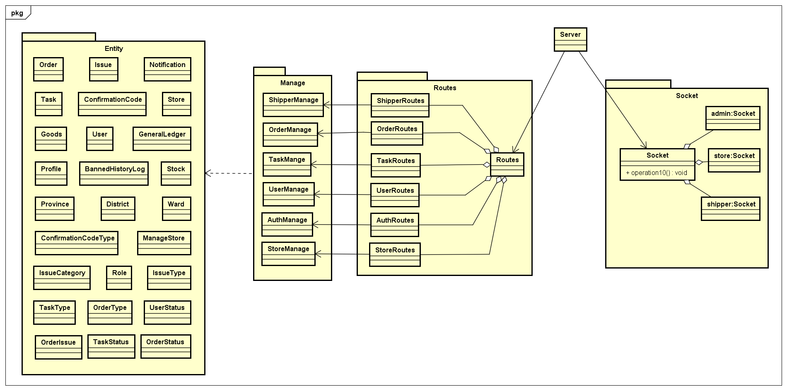

***CLASS DESCRIPTION***

1. Manage
2. ShipperManage

Attributes

|  |  |  |  |  |
| --- | --- | --- | --- | --- |
| No | Attributes | Type | Default | Description |
| N/A | N/A | N/A | N/A | N/A |

Methods

|  |  |  |  |  |
| --- | --- | --- | --- | --- |
| No | Methods | Parameters | Return | Description |
| 1 | getTasks | String | Object | Return an object that hold info of all un-finished tasks regard to shipperID; throw error messages when get error |
| 2 | getHistory | String, int | Object | Return tasks done or fail regard to shipperID and current page to display |
| 3 | getDetail | String, int | Object | Return detail information of an task regard to shipperID and taskid |
| 4 | getOrderStatusList | N/A | Object | Return the object contents all the status of tasks |
| 5 | nextStep | N/A | String | Change the status of order to next step, change status of task; send socket notification to shipper and admin. Return a message success or error. |
| 6 | createIssuePending | String, Object, Array, int | Object | Create a new pending issue and add related order into database  Return the created issue |
| 7 | changeIsPending | String, int | N/A | Resolve an issue and send socket message to the store owns that order |
| 8 | getAllShipper | N/A | Array | Return list of all shippers |
| 9 | getAllOrderToAssignTask | N/A | Array | Return list of all orders that assignable in database |
| 10 | getAllShipperWithTask | N/A | Array | Return list of all shippers and their current tasks |
| 11 | getAllShipperWithTaskForProcessing | N/A | Array | Return list of shippers are having issue |
| 12 | updateTaskForShipper | Array | Object | Update information of a task |
| 13 | getShipperStatus | String | boolean | Get status of shipper by shipperID |
| 14 | getTaskBeIssuePending | String | Array | Get list of task is pending because the shipper got issue |
| 15 | countTaskOfShipper | String | int | Count current task of the shipper by shipperID |
| 16 | changeShipperStatus | String, boolean | String | Change status of shipper to on or off, return message success or error |
| 17 | createShipperID | N/A | String | Create an unique and valid ID for new shipper |

1. IssueManage

Attributes

|  |  |  |  |  |
| --- | --- | --- | --- | --- |
| No | Attributes | Type | Default | Description |
| N/A | N/A | N/A | N/A | N/A |

Methods

|  |  |  |  |  |
| --- | --- | --- | --- | --- |
| No | Methods | Parameters | Return | Description |
| 1 | getAllIssue | N/A | Array | Get list of all issues in database |
| 2 | getIssueDetail | int | Object | Get detail information of an issue |
| 3 | updateResolveIssue | int, int | Object | Resolve an issue with type of resolve |
| 4 | postBannedLog | Object | Object | Ban a user cause of some reason |
| 5 | createIssueDisconnect | String | Object | Auto raise an issue when shipper disconnect away the socket server in period time |
| 6 | getUserHasIssue | N/A | Array | Get all users who are having un-resolved issue |

1. UserManage

Attributes

|  |  |  |  |  |
| --- | --- | --- | --- | --- |
| No | Attributes | Type | Default | Description |
| N/A | N/A | N/A | N/A | N/A |

Methods

|  |  |  |  |  |
| --- | --- | --- | --- | --- |
| No | Methods | Parameters | Return | Description |
| 1 | getProfileUser | String | Object | Get profile of a user |
| 2 | getUserDetail | String | Object | Get detail information of a user |
| 3 | putUser | Object | Object | Update data of a user |
| 4 | putProfile | Object | Object | Update profile for a shipper |
| 5 | addNewUser | Object | Object | Create a new user |

1. StoreManage

Method

|  |  |  |  |  |
| --- | --- | --- | --- | --- |
| No | Methods | Parameters | Return | Description |
| 1 | get | N/A | Array | Get all stores |
| 2 | postNewStore | N/A | Object | Add new Store to database |
| 3 | put | N/A | Object | Update Store with new information to database |
| 4 | getLatestLedgerOfStore | String | Object | Get latest ledger information of specific store |
| 5 | getAllStoreWithLedger | N/A | Array | Get all stores with information of ledger |
| 6 | getTotalFee | N/A | Array | Get total fee of all stores |
| 7 | getTotalCoD | N/A | Array | Get total cash on delivery of all stores |
| 8 | getLatestAutoAccountDate | N/A | Date | Get latest date of ledger that is added automatically by system |
| 9 | updateLedgerForOrder | int | Object | Update which ledger is paid for order |
| 10 | postNewLedger | Object | Object | Add new ledger (transaction) to database |
| 11 | getStoreName | Array | Array | Get list store’s name by storeid |
| 12 | getStoreDetail | String | Object | Get detail of store by storeid |
| 13 | createStoreOwnerID | N/A | String | Create new username for new store owner |
| 14 | createStoreID | N/A | String | Create new storeid for new store |
| 15 | postNewManageStore | N/A | Object | Add relation of new store’s owner and new Store is managed by this store’s owner to database |
| 16 | getAllLedger | N/A | Array | Get all transaction |
| 17 | getLedgerOfStore | String, Date | Array | Get all ledgers of specific store after specific date |
| 18 | storeGetAllLedger | String | Object | Get all ledgers of specific store |

1. OrderMange

Attributes

|  |  |  |  |  |
| --- | --- | --- | --- | --- |
| No | Attributes | Type | Default | Description |
|  | wardID | String | N/A | ID of ward |
|  | name | String | N/A | Name of ward |
|  | type | String | N/A | Type of ward |
|  | districtID | String | N/A | ID of district has ward |
|  | location | String | N/A | Location of ward in map |

Methods

|  |  |  |  |  |
| --- | --- | --- | --- | --- |
| No | Methods | Parameters | Return | Description |
| 1 | getAllOrder | String | Array | Get all order of store by storeID |
| 2 | calculateShipFee | String, Array, int | double | Calculate ship fee for an Order |
| 3 | calculateOverWeightFee | String, Array, Array | double | Calculate over weight fee for an Order |
| 4 | GenerateRandomCode | int | String | Create confirm codes for an Order |
| 5 | postOneOrder | Object | Object | Create new order into order table |
| 6 | updateOrder | Object | Object | Update order when user edit info of an order |
| 7 | deleteOrder | String | int | Delete an order in order table |
| 8 | putDraff | Object | Object | Add new draft order in order table |
| 9 | cancelOrder | Object | Object | Request cancel order from Store. Insert new row data into issue table, notification table and notify to Admin |
| 10 | getOrderList | Object | Array | Get all order list from order table |
| 11 | getTodayTotal | N/A | Array | Calculate total COD and Fee of all stores |
| 12 | storeGetOrderList | String | Array | Get list order of a store |
| 13 | countOrder | String | Array | Calculate total of order by month or year of a store. |
| 14 | getOverView | N/A | Array | Get all orders, stores, shipper, fee of system to statistical |
| 15 | pushIntoArray | Array, Object | int | Push Item into Array. If item not exist in array, then add item in array. If item exist in array, then update item.  Return index of item in array |
| 16 | getOrderCount | N/A | Array | Get number order of store by month, year |
| 17 | getMoneyCount | N/A | Array | Get total fee and cod of all orders of store |
| 18 | getCountOrdersDoneOrFail | N/A | Array | Count number of done orders and fail orders of all stores |
| 19 | getProvince | N/A | Array | Get all provinces |

1. Entity
2. Bannedhistorylog

|  |  |  |  |  |
| --- | --- | --- | --- | --- |
| No | Attributes | Type | Default | Description |
|  | logID | int | N/A | Unique id of log |
|  | adminID | String | N/A | Id of admin |
|  | shipperID | String | N/A | ShipperID is banned or unbanned |
|  | storeID | String | N/A | StoreID is banned or unbanned |
|  | Reason | String | N/A | Reason of ban |
|  | bannedTime | Date | N/A | Time of ban |
|  | Type | String | N/A | Types of ban: ban or unban |

|  |  |  |  |  |
| --- | --- | --- | --- | --- |
| No | Methods | Parameters | Return | Description |
| 1 | postNewLog | Object | Object | Insert new row data in bannedhistorylog table. |

1. Confirmationcode

|  |  |  |  |  |
| --- | --- | --- | --- | --- |
| No | Attributes | Type | Default | Description |
| 1 | codeID | Int | N/A | Unique id of confirmation code |
| 2 | typeID | Int | N/A | ID of code type |
| 3 | orderID | String | N/A | ID of order |
| 4 | codeContent | int | N/A | Content of code |

|  |  |  |  |  |
| --- | --- | --- | --- | --- |
| No | Methods | Parameters | Return | Description |
| 1 | postOneCode | Object | Object | Insert new row data in confirmationcode table |
| 2 | deleteConfirmCode | int | int | Delete a row data in confirmationcode table |
| 3 | putOrder | Object | Object | Update a row data in confirmationcode table |
| 4 | checkCode | String, int, int | Object | Check code is respective with orderID, taskID and orderstatus. |

1. Confirmationcodetype

|  |  |  |  |  |
| --- | --- | --- | --- | --- |
| No | Attributes | Type | Default | Description |
| 1 | typeID | int | N/A | Unique id of code type |
| 2 | codeType | String | N/A | Type of code: Pickup order, delivery order,… |

1. District

|  |  |  |  |  |
| --- | --- | --- | --- | --- |
| No | Attributes | Type | Default | Description |
| 1 | districtID | String | N/A | ID of district |
| 2 | Name | String | N/A | Name of district |
| 3 | Type | String | N/A | Type of district |
| 4 | provinceID | String | N/A | ID of province has district |

|  |  |  |  |  |
| --- | --- | --- | --- | --- |
| No | Methods | Parameters | Return | Description |
| 1 | getAllDistrict | N/A | Array | Get All District from district table. |

1. Generalledger

Attributes

|  |  |  |  |  |
| --- | --- | --- | --- | --- |
| No | Attributes | Type | Default | Description |
| 1 | ledgerID | int | N/A | Unique id of ledger |
| 2 | adminID | String | N/A | Who added this ledger |
| 3 | storeID | String | N/A | ID of store who sends or receives payment |
| 4 | amount | int | N/A | Amount of payment |
| 5 | totalDelivery | int | N/A | Delivery cost |
| 6 | totalCOD | int | N/A | CoD cost |
| 7 | balance | int | N/A | Balance after payment |
| 8 | payDate | Datetime | N/A | When ledger is posted |
| 9 | note | String | N/A | Note |
| 10 | payFrom | int | N/A | Ledger is from store or system |

Methods

|  |  |  |  |  |
| --- | --- | --- | --- | --- |
| No | Methods | Parameters | Return | Description |
| 1 | getLatestLedgerOfStore | String | Object | Get lastest ledger by storeID |
| 2 | getLatestAutoAccountDate | N/A | Object | Get lastest date of ledger which calculated by system. |
| 3 | postNewLedger | Object | Object | Insert new row data in generalledger table. |
| 4 | getLedgerOfStore | String, Date, Date | Object | Get ledger by Store. |

1. Goods

|  |  |  |  |  |
| --- | --- | --- | --- | --- |
| No | Attributes | Type | Default | Description |
| 1 | goodsID | int | N/A | Unique id of goods |
| 2 | goodsName | String | N/A | Name of goods |
| 3 | orderID | String | N/A | ID of order contains goods |
| 4 | weight | float | N/A | Weight of goods |
| 5 | lengthSize | float | N/A | LengthSize of goods |
| 6 | widthSize | float | N/A | WidthSize of goods |
| 7 | heightSize | float | N/A | HeightSize of goods |
| 8 | description | String | N/A | Description of goods |
| 9 | amount | int | N/A | Amount of goods |

|  |  |  |  |  |
| --- | --- | --- | --- | --- |
| No | Methods | Parameters | Return | Description |
| 1 | postOneGood | Object | Object | Add new row data in goods table. |
| 2 | deleteGoodsByID | Int | int | Delete a row data in goods table by goodsID |
| 3 | updateGoods | Object, int | Object | Update row data in goods table by goodsID |
| 4 | checkGoodsBelongStore | int, String | Object | Check goods belongs to order of store |
| 5 |  |  |  |  |

1. Issue

|  |  |  |  |  |
| --- | --- | --- | --- | --- |
| No | Attributes | Type | Default | Description |
| 1 | issueID | int | N/A | ID of issue |
| 2 | typeID | int | N/A | ID of issue type |
| 3 | isResolved | boolean | N/A | Issue is resolved or not |
| 4 | description | String | N/A | Description |
| 5 | resolveType | int | N/A | Type of resolve |
| 6 | createdDate | Date | N/A | When issue is created |
| 7 | sender | String | N/A | Who sent issue |

|  |  |  |  |  |
| --- | --- | --- | --- | --- |
| No | Methods | Parameters | Return | Description |
| 1 | createNewIssue | Object | Object | Add new row data in issue table. |
| 2 | changeIsPendingOfShipper | int, String, int | Array | Get issue of shipper with category is pending to resolve this issue. |
| 3 | getAllIssue | int | Array | Get All issue by issuetype |
| 4 | getIssueDetail | int | Object | Get detail information of issue |
| 5 | updateResolveIssue | int, int | Object | Update way to resolve an issue by issueid |
| 6 | getUserGetIssue | N/A | Array | Get user got issue |
| 7 | getIssueBySender | String | Object | Get issue by sender. |

1. Issuecategory

|  |  |  |  |  |
| --- | --- | --- | --- | --- |
| No | Attributes | Type | Default | Description |
| 1 | categoryID | int | N/A | ID of category |
| 2 | categoryName | String | N/A | Category of issue: Shipper Pending,... |

1. Issuetype

|  |  |  |  |  |
| --- | --- | --- | --- | --- |
| No | Attributes | Type | Default | Description |
| 1 | typeID | int | N/A | ID of type |
| 2 | typeName | String | N/A | Name of type |
| 3 | categoryID | int | N/A | ID of issue category |

1. Managestore

|  |  |  |  |  |
| --- | --- | --- | --- | --- |
| No | Attributes | Type | Default | Description |
| 1 | managerID | String | N/A | Unique id of manager |
| 2 | storeID | String | N/A | Unique id of store |

|  |  |  |  |  |
| --- | --- | --- | --- | --- |
| No | Methods | Parameters | Return | Description |
| 1 | getStoresOfUser | String, String | Object | Get store owner by managerID |
| 2 | getUsersByStoreID | String | Object | Get User by storeID |
| 3 | addNewManageStore | Object | Object | Add new row data in managestore table |

1. Notification

|  |  |  |  |  |
| --- | --- | --- | --- | --- |
| No | Attributes | Type | Default | Description |
| 1 | notificationID | int | N/A | Unique id of notification |
| 2 | type | String | N/A | Type of notification: info, error |
| 3 | title | String | N/A | Title of notification |
| 4 | content | String | N/A | Content of notification |
| 5 | url | String | N/A | URL link to page relate to notification |
| 6 | isRead | boolean | N/A | Notification has been read or hasn’t |
| 7 | username | String | N/A | Who receive notification |
| 8 | createDate | Date | N/A | When notification is created |

|  |  |  |  |  |
| --- | --- | --- | --- | --- |
| No | Methods | Parameters | Return | Description |
| 1 | getTotalNumberOfNotifications | String | int | Count total of Notifications |
| 2 | getTotalUnreadNotifications | String | Int | Count total of unread Notifications |
| 3 | addNotification | Object | Object | Add new row data in notification table |
| 4 | updateNotification | Object | Object | Update notification by notificationID |

1. Orderissue

|  |  |  |  |  |
| --- | --- | --- | --- | --- |
| No | Attributes | Type | Default | Description |
| 1 | issueID | int | N/A | ID of issue |
| 2 | orderID | int | N/A | ID of order which has issues |

|  |  |  |  |  |
| --- | --- | --- | --- | --- |
| No | Methods | Parameters | Return | Description |
| 1 | createOrderIssue | Object | Object | Add new row data in orderissue table |
| 2 | getOrderOfIssue | int | Array | Get order by issueID in orderissue table |

1. Order

Attributes

|  |  |  |  |  |
| --- | --- | --- | --- | --- |
| No | Attributes | Type | Default | Description |
|  | orderID | String | N/A | Unique id of orders |
|  | storeID | String | N/A | ID of store |
|  | stockID | int | N/A | ID of stock contains order |
|  | orderTypeID | int | N/A | typeID of orders |
|  | pickUpAddress | String | N/A | Address for picking up order |
|  | deliveryAddress | String | N/A | Address for delivering up order |
|  | pickUpDate | Date | N/A | Date of picking up order |
|  | completeDate | Date | N/A | Date of delivering order |
|  | createDate | Date | N/A | Date of creating order |
|  | recipientPhone | String | N/A | Phone of recipient |
|  | recipientName | String | N/A | Recipient’s Name |
|  | ledgerID | int | N/A | ID of ledger of order |
|  | statusID | int | N/A | ID of order status |
|  | goods | int | N/A | ID of goods |
|  | fee | int | N/A | Fee of order |
|  | CoD | int | N/A | Cash on delivery |
|  | Overweightfee | int | N/A | Fee of overweight |
|  | deliveryProvinceID | int | N/A | ID of province of delivery address |
|  | deliveryDistrictID | int | N/A | ID of district of delivery address |
|  | deliveryWardID | int | N/A | ID of ward of delivery address |

Methods

|  |  |  |  |  |
| --- | --- | --- | --- | --- |
| No | Methods | Parameters | Return | Description |
| 1 | getAllTaskOfShipper | String | Array | Get all task of shipper by shipperID. |
| 2 | getLastestTasksOfShipper | String | Array | Get lastest tasks of shipper by shipperID |
| 3 | getStoresOfOrder | String | Array | Get store by orderID |
| 4 | getOrderDetailById | int, int | Object | Get order’s detail by orderID |
| 5 | storeGetAllOrders | String | Array | Get All order by storeID |
| 6 | storeGetOneOrder | String | Object | Get one order by orderID |
| 7 | updateExpressOrder | String | Object | Update Express order by orderID |
| 8 | changeIsPendingOrder | String, boolean | Object | Update isPending field of order in order table. |
| 9 | submitDraffOrder | String | Object | Add new row data in order table and isdraff is false. |
| 10 | getTotalShipFeeOfStore | String, Date | int | Sum fee of a store |
| 11 | deleteDraffOrder | String, Date | int | Delete a row data in order table by orderID. |
| 12 | getTotalShipCoDOfStore | String, Date | int | Sum COD of a store |
| 13 | cancelOrder | String | Object | Update iscancel is true by orderID |
| 14 | updateLedgerForOrder | String, Date, int | Object | Update ledger of store on completedate |
| 15 | getAllOrderToAssignTask | N/A | Array | Get all order which can be assign to other shipper |
| 16 | getTaskBeIssuePending | String | Array | Get Task have issue. Check shipper got an issue. |
| 17 | adminCountAllOrder | N/A | Array | Count number order and fee of all stores |
| 18 | adminCountOrdersDoneOrFail | N/A | Array | Count number of done orders and fail orders of all stores |
| 19 | adminGetMoneyStatisticOrders | N/A | Array | Get total fee and cod of all orders of store |
| 20 | adminGetAllStatisticOrders | N/A | Array | Get number order of store by month, year |
| 21 | countOrder | String | Array | Count order in month or year |
| 22 | updateOrder | String, int | Object | Update order with new information |
| 23 | updateOrderAfterStoreCancel | Object | Object | Update status and fee of order after store cancelled it |
| 24 | updateOrderStatus | Object | Object | Update Status of order |
| 25 | getTodayTotalCoD | N/A | int | Get total cash on delivery today |
| 26 | getTodayTotalDelivery | N/A | int | Get total delivery cost today |
| 27 | shipperGetOneOrder | int, String, String | Object | Get information of shipper take order of specific task |
| 28 | getAllOrder | N/A | Array | Get all order with status, type and store |

1. Ward

|  |  |  |  |  |
| --- | --- | --- | --- | --- |
| No | Attributes | Type | Default | Description |
|  | wardID | String | N/A | ID of ward |
|  | name | String | N/A | Name of ward |
|  | type | String | N/A | Type of ward |
|  | districtID | String | N/A | ID of district has ward |
|  | location | String | N/A | Location of ward in map |

|  |  |  |  |  |
| --- | --- | --- | --- | --- |
| No | Methods | Parameters | Return | Description |
| 1 | getAllWard | N/A | Array | Get all ward |

1. UserStatus

|  |  |  |  |  |
| --- | --- | --- | --- | --- |
| No | Attributes | Type | Default | Description |
| 1 | statusID | int | N/A | Unique id of status |
| 2 | statusName | String | N/A | Status of user: ban, unban, active,… |

1. User

Attributes

|  |  |  |  |  |
| --- | --- | --- | --- | --- |
| No | Attributes | Type | Default | Description |
| 1 | username | String | N/A | unique username for each user |
| 2 | password | String | N/A | Password of username in BCRYPT format |
| 3 | userRole | int | N/A | roleID of username |
| 4 | userStatus | int | N/A | statusID of username |
| 5 | logintime | Date | N/A | Last time that user logged in |

Methods

|  |  |  |  |  |
| --- | --- | --- | --- | --- |
| No | Methods | Parameters | Return | Description |
| 1 | encryptPassword | String | String | Encrypt password from string to BCRYPT format |
| 2 | getAllUser | N/A | Array | Get all users |
| 3 | getAllUserHasRole | int | Array | Get all users has specific role |
| 4 | findUserByUsername | String | Object | Get one user has specific username |
| 5 | findUserDetail | String | Object | Get one user has specific username with profile |
| 6 | addNewUser | Object | Object | Add new user to database |
| 7 | putUser | Object | Object | Update user’s information |
| 8 | getAllShipperWithTask | N/A | Array | Get all shippers with their task and related information |
| 9 | getAllTaskProcessingOfShipper | String | Array | Get all shippers with their processing task |
| 10 | updateLoginTime | String, Date | Object | Update login time of user |
| 11 | checkTokenTime | String, Date | Object | Check token is valid or not |
| 12 | updateUserStatus | String, int | Object | Update status of user |

1. TaskType

Attributes

|  |  |  |  |  |
| --- | --- | --- | --- | --- |
| No | Attributes | Type | Default | Description |
| 1 | typeID | int | N/A | ID of type |
| 2 | typeName | String | N/A | Name of type |

Methods

|  |  |  |  |  |
| --- | --- | --- | --- | --- |
| No | Methods | Parameters | Return | Description |
| 1 | getAllTaskType | N/A | Array | Get all types of task |

1. TaskStatus

Attributes

|  |  |  |  |  |
| --- | --- | --- | --- | --- |
| No | Attributes | Type | Default | Description |
| 1 | statusID | int | N/A | ID of status |
| 2 | statusName | String | N/A | Name of status |

Methods

|  |  |  |  |  |
| --- | --- | --- | --- | --- |
| No | Methods | Parameters | Return | Description |
| 1 | getAllTaskStatus | N/A | Array | Get all status of task |

1. Task

Attributes

|  |  |  |  |  |
| --- | --- | --- | --- | --- |
| No | Attributes | Type | Default | Description |
| 1 | taskID | int | N/A | Unique username of profile |
| 2 | statusID | int | N/A | Full name |
| 3 | adminID | String | N/A | Identity Card |
| 4 | shipperID | String | N/A | Address |
| 5 | orderID | String | N/A | Date of birth |
| 6 | typeID | int | N/A | Email |
| 7 | taskDate | Date | N/A | When task is created |

Methods

|  |  |  |  |  |
| --- | --- | --- | --- | --- |
| No | Methods | Parameters | Return | Description |
| 1 | getAllHistoryOfShipper | String | Array | Get history all tasks of shipper |
| 2 | countTotalTaskHistoryOfShipper | String | Object | Count total tasks of shipper |
| 3 | updateStatusOfTask | int, int | Object | Update status of specific task |
| 4 | updateShipperOfTask | int, String | Object | Update shipper of specific task |
| 5 | assignTaskForShipper | Object | Object | Assign task for shipper |
| 6 | createTaskForShipper | Object | Object | Create new task for shipper |
| 7 | getAllTask | N/A | Array | Get all tasks |
| 8 | updateTaskState | Object | Object | Update status and type of task |
| 9 | getTaskOfShipperByOrder | String, String | Array | Get all task of specific order |
| 10 | countProcessingTaskForShipper | String | int | Number of processing task of shipper |
| 11 | deleteTask | Object | int | Delete specific task |
| 12 | adminCountTaskOfEachShipper | N/A | Array | Number task of each shipper |

1. Store

Attributes

|  |  |  |  |  |
| --- | --- | --- | --- | --- |
| No | Attributes | Type | Default | Description |
| 1 | storeID | String | N/A | Unique id of store |
| 2 | name | String | N/A | Store’s name |
| 3 | description | String | N/A | Description about store |
| 4 | address | String | N/A | Address |
| 5 | email | String | N/A | Email |
| 6 | phoneNumber | String | N/A | Phone number |
| 7 | avartar | String | N/A | Link of avatar of store |
| 8 | registeredDate | Date | N/A | Date that store registered |
| 9 | latitude | String | N/A | Latitude of address in map |
| 10 | longitude | String | N/A | Longitude of address in map |

Methods

|  |  |  |  |  |
| --- | --- | --- | --- | --- |
| No | Methods | Parameters | Return | Description |
| 1 | getAllStores | N/A | Array | Get all stores |
| 2 | getOneStore | String | Object | Get one store |
| 3 | postOneStore | Object | Object | Add new Store |
| 4 | deleteStore | Object | int | Delete specific Store |
| 5 | updateStore | Object | Object | Update Store with new information |
| 6 | getAllStoreWithLedger | N/A | Array | Get all stores with ledger information |
| 7 | getStoreDetail | String | Object | Get detail of store |
| 8 | adminGetAllStoreNameAndStoreID | N/A | Array | Get name and id of all stores |

1. Stock

Attributes

|  |  |  |  |  |
| --- | --- | --- | --- | --- |
| No | Attributes | Type | Default | Description |
| 1 | stockID | int | N/A | Unique id of stock |
| 2 | name | String | N/A | Stock’s name |
| 3 | address | String | N/A | Address |
| 4 | adminID | String | N/A | ID of admin who manages the stock |

1. Role

Attributes

|  |  |  |  |  |
| --- | --- | --- | --- | --- |
| No | Attributes | Type | Default | Description |
| 1 | roleID | int | N/A | Unique id of role |
| 2 | roleName | String | N/A | Role’s name |

1. Province

Attributes

|  |  |  |  |  |
| --- | --- | --- | --- | --- |
| No | Attributes | Type | Default | Description |
|  | provinceID | String | N/A | ID of province |
|  | name | String | N/A | Name of province |
|  | type | String | N/A | Type of province |

Method

|  |  |  |  |  |
| --- | --- | --- | --- | --- |
| No | Methods | Parameters | Return | Description |
| 1 | getAllProvince | N/A | Array | Get all province |

1. Profile

Attributes

|  |  |  |  |  |
| --- | --- | --- | --- | --- |
| No | Attributes | Type | Default | Description |
|  | username | String | N/A | Unique username of profile |
|  | name | String | N/A | Full name |
|  | identityCard | String | N/A | Identity Card |
|  | address | String | N/A | Address |
|  | DoB | Date | N/A | Date of birth |
|  | email | String | N/A | Email |
|  | avartar | String | N/A | Link of avatar of user |
|  | phoneNumber | String | N/A | Phone number |

Method

|  |  |  |  |  |
| --- | --- | --- | --- | --- |
| No | Methods | Parameters | Return | Description |
| 1 | getProfileUser | String | Object | Get profile of user |
| 2 | addNewProfile | Object | Object | Add new profile of user |
| 3 | updateProfile | Object | Object | Update profile with new information |

1. OrderType

Attributes

|  |  |  |  |  |
| --- | --- | --- | --- | --- |
| No | Attributes | Type | Default | Description |
|  | typeID | int | N/A | ID of order’s type |
|  | typeName | String | N/A | Name of type: normal, express,… |
|  | nextAction | String | N/A | Next action of this type |

1. OrderStatus

Attributes

|  |  |  |  |  |
| --- | --- | --- | --- | --- |
| No | Attributes | Type | Default | Description |
|  | statusID | int | N/A | ID of order’s status |
|  | statusName | String | N/A | Name of order’s status: picking up, delivering,… |

1. COMMON

***401\_ Login***

***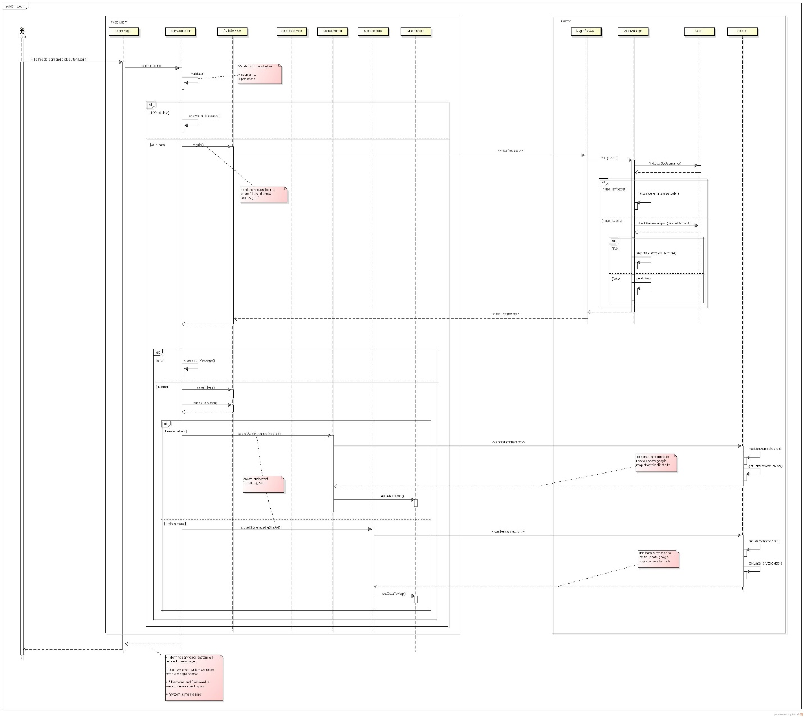***

***402\_ Logout***

***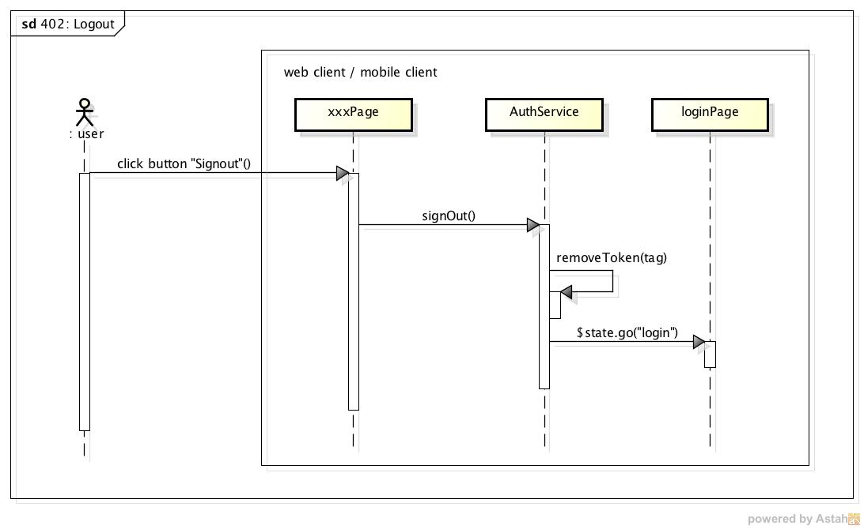***

***403\_ CheckAll***

***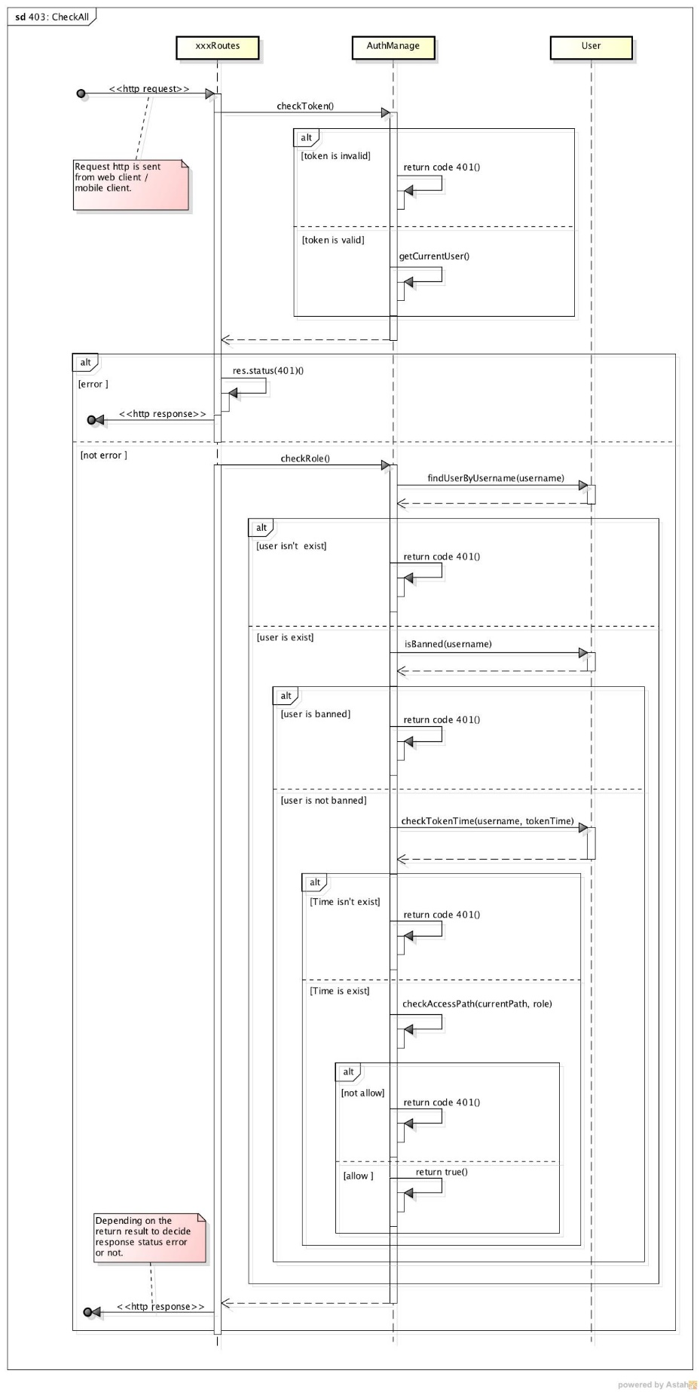***

***404\_ ErrorHandle***

***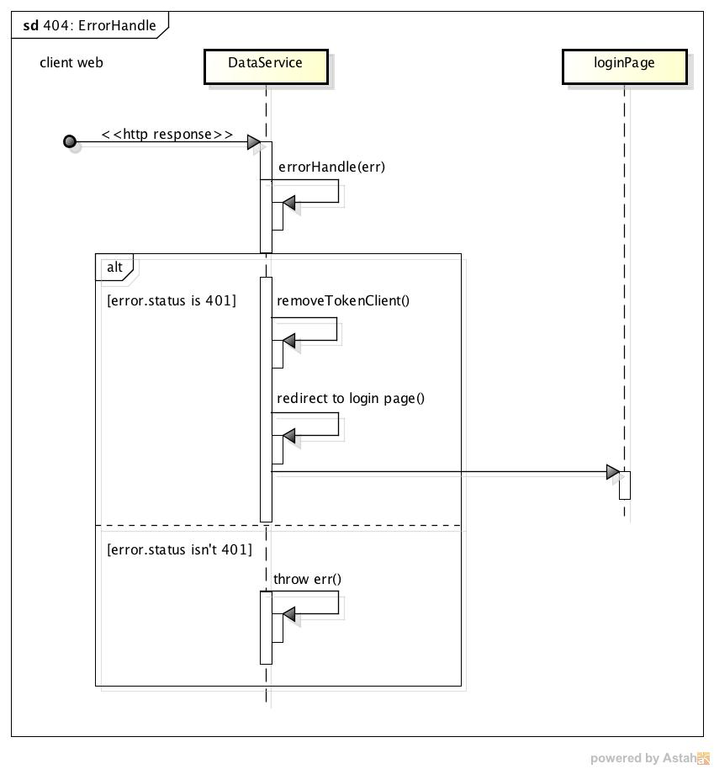***

***405\_ Notification***

***